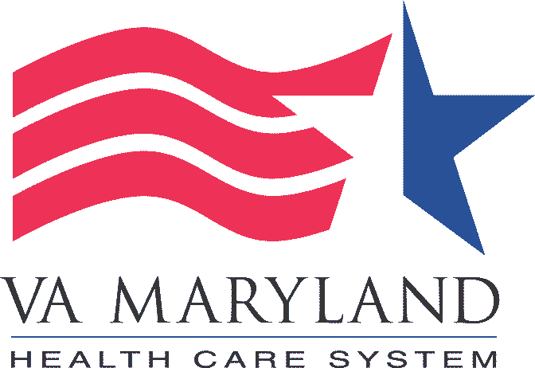
VA INFORMED CONSENT AND HIPAA GUIDELINES

- This template is a combined VA informed consent and HIPAA authorization. The combined form cannot be used in the following conditions:
- The research contains elements of optional banking of data or biospecimens. VA Form 10-0493, Authorization for Use & Release of Individually Identifiable Health Information for Veterans Health Administration (VHA) Research (VA HIPAA Authorization) is still required as it contains information on page 5 related to optional authorization supplement for placing data or biological specimens in a Repository or for conducting optional analysis of specimens for future use in research
- A legally authorized representative will consent and authorize on behalf of the research participant, a VA 10-0493, Authorization for Use & Release of Individually Identifiable Health Information for Veterans Health Administration (VHA) Research (VA HIPAA Authorization) must be used.
- If the above conditions apply to your study, please remove the HIPAA language on this template and use the VA Form 10-0493.
- Items in blue mirror UMB IRB informed consent template instructions. Items in green are VA-specific language or instructions. Other items in black must remain in the final ICD.
- Do not adjust the bottom margin or use the footer; it has been reserved for use by the IRB.
- Follow the guidelines and complete as applicable for your project. Please delete the template guidelines and unwanted text after the document is completed.
- The consent form should include all the section headings indicated in the template unless otherwise indicated.
- The headings of this consent form are generally phrased as questions from the participant; the content of each section is generally written as the response from the study team. The form should provide information that a reasonable person would want to have in order to make an informed decision about whether to participate or not.
- The consent form may not contain exculpatory language through which the participant is made to waive or appear to waive any of the participant’s legal rights, or releases or appears to release the investigator or the Institution from liability for negligence. Phrases such as “I understand…” or “You understand…” are not appropriate as they can be interpreted as suggestive and can constitute coercive influence over a participant.
- The consent form should be written at an appropriate grade level for the group of participants, usually no higher than the 8th grade level based on an electronic grade level scoring system, which is available with most word processing systems. The IRB may consider higher reading grade levels based on the populations targeted in the study.
- The consent form must be organized and presented in a way that does not merely provide lists of isolated facts, but rather facilitates the understanding of the prospective participant or LAR of the reasons why one might or might not want to participate.
- Informed consent is a process, not just a form. The written presentation of information can be used as a teaching tool to document the basis for consent and for the participants' future reference. Obtaining informed consent is a fundamental mechanism to ensure respect for persons through provision of thoughtful consent for a voluntary act. The consent document should be revised when deficiencies are noted or when additional information will improve the consent process.
- The procedures used in obtaining informed consent should be designed to educate potential participants in language that they can understand. If a Principal Investigator proposes to use a participant population that does not speak or read English, a copy of the translated document, as well as the English version, needs to be forwarded to the IRB for approval.
- For projects involving VA employees as participants, Principal Investigators need to carefully review the template and not include any elements that may not pertain to these types of studies, such as statements involving usual care, alternate treatments, or current relationships with participant’s health care providers.
- Collection of full name and last 4 of SSN are needed for studies where the consent form will be filed in the medical record

WRITING TIPS THAT MEETS READABILITY REQUIREMENTS:
- Use as few words with three or more syllables as possible
- Break all compound sentences into separate short sentences.
- Use simple, declarative statements where possible.
- Change all passive voice sentences to active voice.
- Proofread for spelling, typographical, and grammatical errors.
- Avoid imbedding list in phrases, instead breakdown into bullets or into a numbered list
- Use tables to present information such as visits, procedures and compensation

ADDITIONAL NOTES FOR STUDY TEAM:
- Informed consent is a process, not just a form. The written presentation of information can be used as a teaching tool to document the basis for consent and for the participants' future reference. Obtaining informed consent is a fundamental mechanism to ensure respect for persons through provision of thoughtful consent for a voluntary act. The consent document should be revised when deficiencies are noted or when additional information will improve the consent process.
- The procedures used in obtaining informed consent should be designed to educate potential participants in language that they can understand. If an investigator proposes to use a participant population that does not speak or read English, a copy of the translated document, as well as the English version, needs to be forwarded to the IRB for approval.
- For projects involving VA employees as participants investigators need to carefully review the template and not include any elements that may not pertain to these types of studies, such as statements involving usual care, alternate treatments, or current relationships with participant’s health care providers.

