MS Teams Calling – Receiving Calls
Once an employee has been migrated to MS Teams Calling, both internal and external calls can be received on your computer or Smartphone.
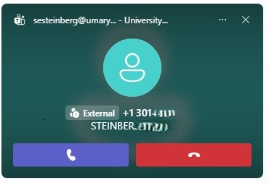
(Screenshot of an external call notification pop-up on a PC. An internal call will also include the option to receive as a video call.)

From a UMB Contact (Internal)
Through the desktop or web application:
- If you receive a call from someone on campus, you will be notified through a pop-up window on your screen, similar to the above screenshot.
- Select the camera icon to answer with your video capabilities and the telephone icon to answer with audio capabilities only.
Through the mobile application
- The incoming call will use your device's default method of showing an incoming call with the contact's name and it will indicate that it is coming from Microsoft Teams.
- Select the video icon to answer with your video capabilities and the telephone icon to answer with audio capabilities only.

From External Contacts
Through the desktop or web application
- If you receive a call from an external contact, the phone number or ID of the caller will appear in a pop-up window on your screen.
- Select the telephone icon to answer the call.
Through the mobile application
- The incoming call will use your device's default method of showing an incoming call with the contact's phone number or ID.
- Select your phone's call answer button to pick up the call.

