MS Teams Calling – Placing Calls
Once an employee has been migrated to MS Teams Calling, both internal and external calls can be placed via the Calls tab in the Teams application.

Teams Application on a Computer
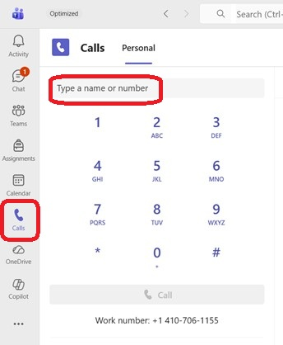
- Within the Teams application, click on the Calls icon in the left-hand navigation panel.
- In the Type a name or number field, enter a phone number or enter a name if they are internal to UMB.
  - 5-digit dialing is allowed to 6-xxxx, 8-xxxx and 41-xxx/42-xxx.
  - Any call can be made by dialing a 10-digit number (area code + number). A “9” should not be used.
- Click the Call button to make the call.
If the call is internal, the option for a video call will also be available.

Teams Application on a Smartphone
Download the Teams App from the App Store on your Smartphone.
- Tap the …More icon in the lower right corner of the app.
- Tap Calls icon.
- Tap the phone+ icon in the lower right corner.
- Use either the Dialpad to enter the phone number you wish to call, or use the People tab to search the UMB directory for the person you wish to call.
- Tap the Phone icon to make the call.

