MS Teams Calling Overview
MS Teams Calling brings chat, video and phone into a single application that UMB already utilizes. Both internal and external calls can be received and made through Teams Calling. Below is an overview of the Calls tab within Teams, which provides access to Teams Calling.
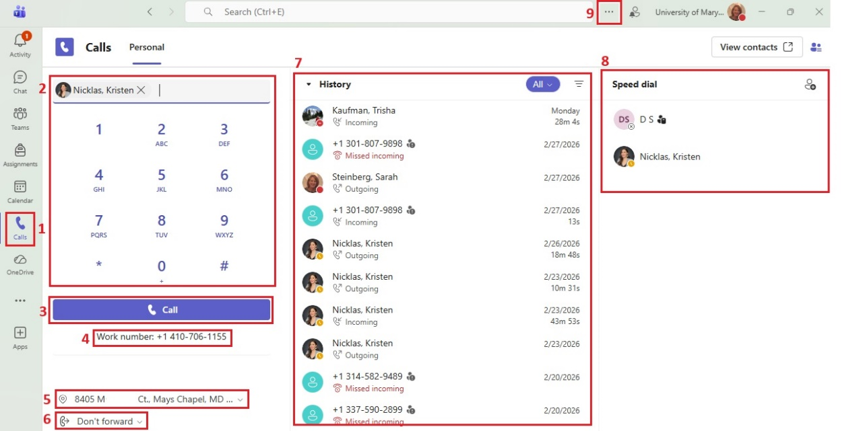
- Calls tab – the main area to place calls
- Dial pad – enter a phone number or enter a name if they are internal to UMB.
  - 5-digit dialing is allowed to 6xxxx, 8xxxx and 41xxx/42xxx.
  - Any call can be made by dialing a 10-digit number (area code + number).
- Call button – click to place a call once a name or number has been entered (the button will say Call as myself if you are set as someone’s delegate).
- Your work number – your UMB phone number.
- Emergency location –
  - When on campus, the system will know your location and it cannot be changed.
  - When remote, each user must add/update their location. See “Emergency Location” section for further information.
- Call forwarding – click the drop-down to set call forwarding settings.
- History – list of recent missed/incoming/outgoing calls and voicemail.
- Speed dial – list of users address to speed dial. Click the Person icon to the far right to add someone.
- Ellipses – select to view menu and select Settings to view all Teams settings.

