Purpose
To provide instructions on how to fill out the Child Request Form
Applicability
This applies to Departmental Administrators, Parent Project PI, Child Project PI, Child Project Chairman, SPAC and SPA

Instruction
Link to form
DocuSign
Filling out the form
Instruction on Filling Form
Departmental Administrator
(Or person filling out the form)
Full name & email address
You will receive and email to fill in all of the required fields on the form

Fill in Parent Project
PI full name & email address

Required approver

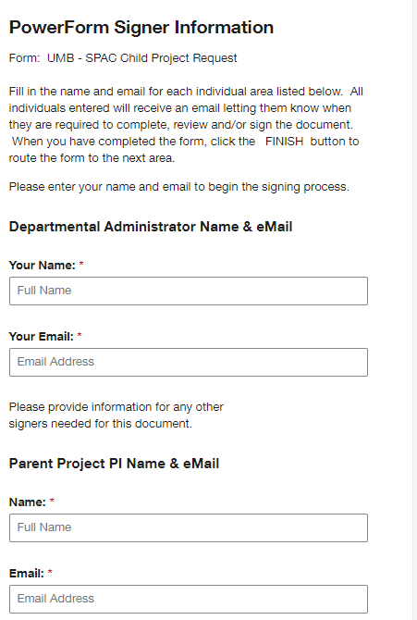
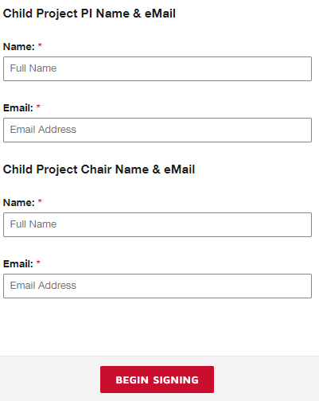
Departmental Administrator (cont.)

Fill in Child Project PI Name and email address
Required Approver

Fill in Child Project Chair Name and email address
Required Approver

Hit “Begin Signing” to submit your form for signatures

Those listed by name above will receive an email similar to the one below in the order of the required actions:
1st - Departmental Administrator or designee to complete the form
2cd- Parent Project PI for signature approval
3rd – Child Project PI for signature approval
4th - Child Project Chair PI signature approval

Departmental Administrator
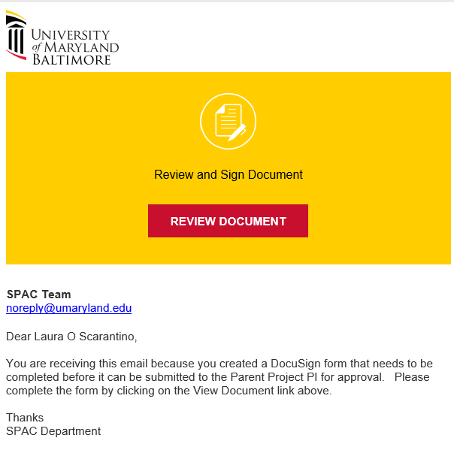
When you click into on your email
And then choose on the header
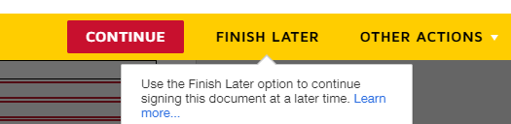

This will take you into the form. You will be required to fill the red highlighted boxes in order for the form to move forward for its first approval. The form will not submit if all fields are not filled in. Once you have completed the 2 pages, hit the button.
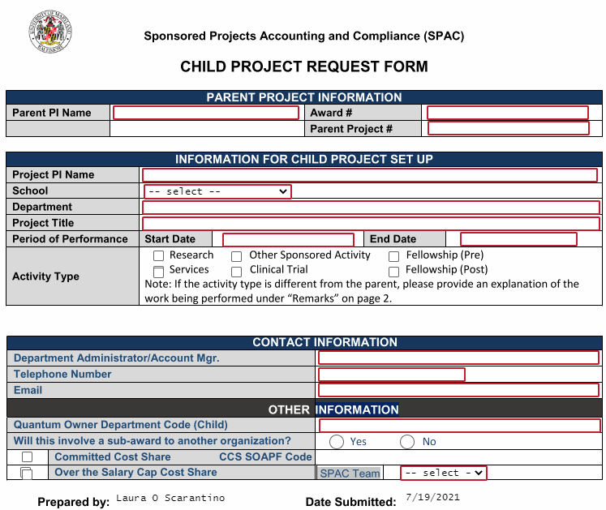

NOTE FOR SPAC TEAM CHOICE: IT DEFAULTS TO SETUP
- This form will automatically route to the setup team
- No need to make a choice

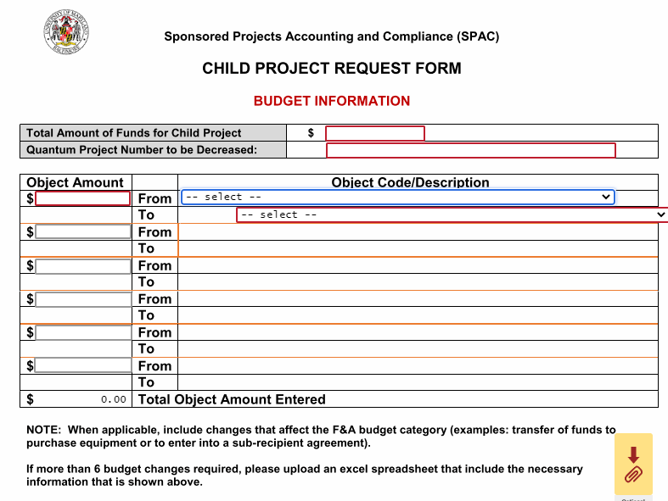
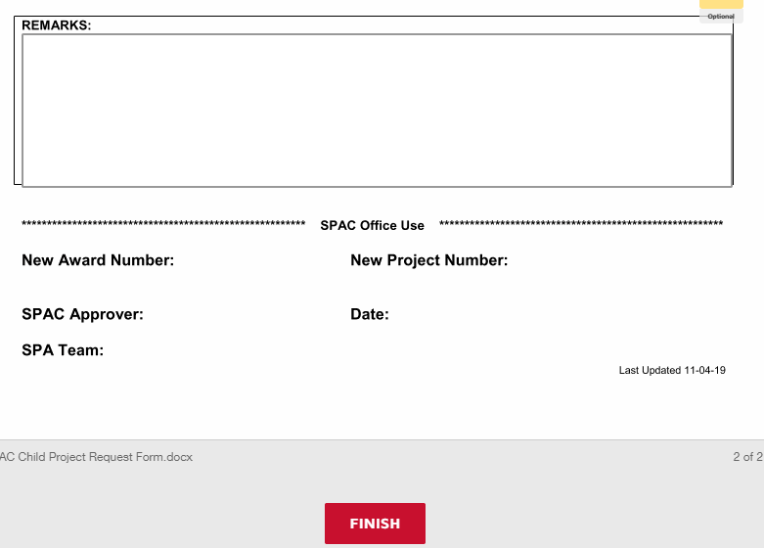
******You can (optional) download or print a copy of the document that you filled out or close****
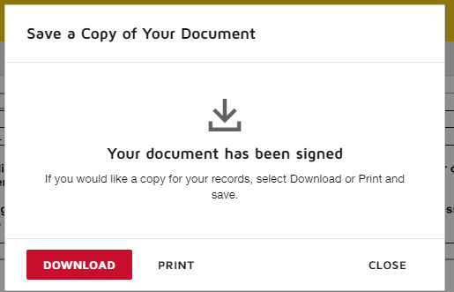
Department Admin – you are done for now

PARENT PI/CHILD PI OR CHILD PROJECT CHAIR
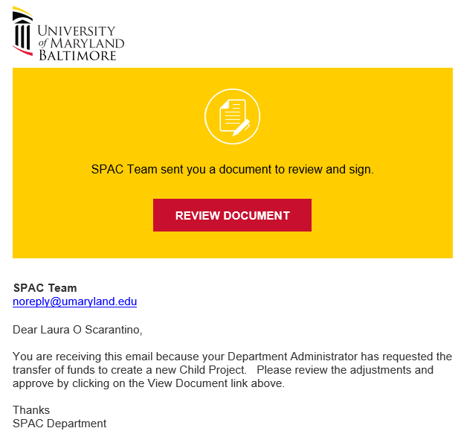
When you click into on your email
And then choose on the header
This will take you to the required signatures page. Of course you should review before you sign.
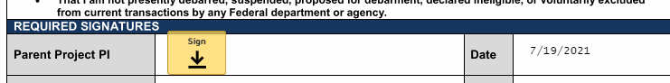
When you hit the 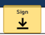 button, a box will pop up with My Signatures and Initials. You would either use a saved signature or adopt a new one
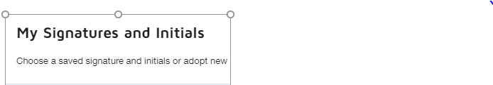
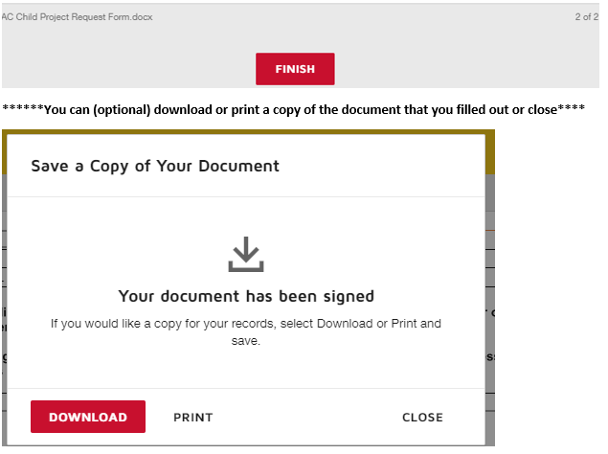
PI or Chair you are done for now!

SPAC TEAM
You will receive an email in your inbox. This email will automatically move to your workflow.

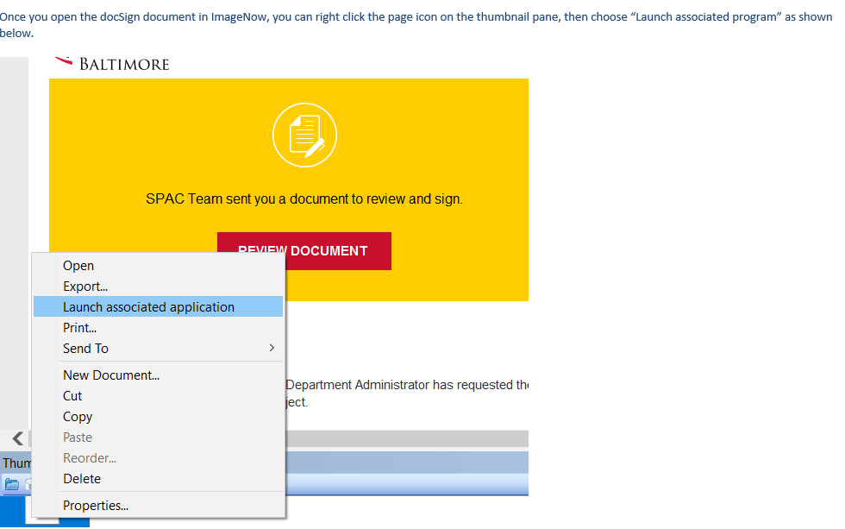

Sign onto your DocuSign Account
You will then perform the action of creating the child project per the instructions provided on the form. Once completed, scroll to the bottom of the form and fill in the award # and project number and click on the SPAC Approver “sign” line to sign the form

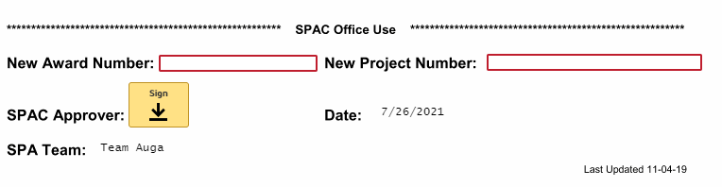
And then click the button.

Make sure that before you send the DocuSign file to WFE that you fill in the properties for the child setup, if it was not already filled in during the transfer to Account Maintenance workflow
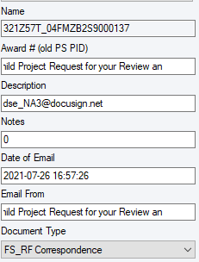

When SPAC hits the “finish” button, a copy of the document goes to Team-Aqua in SPA and is copied out to everyone who was a signer on the document. Those who signed on the document will receive the following email.
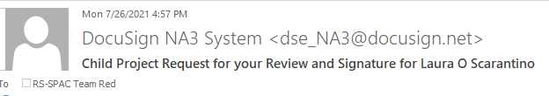
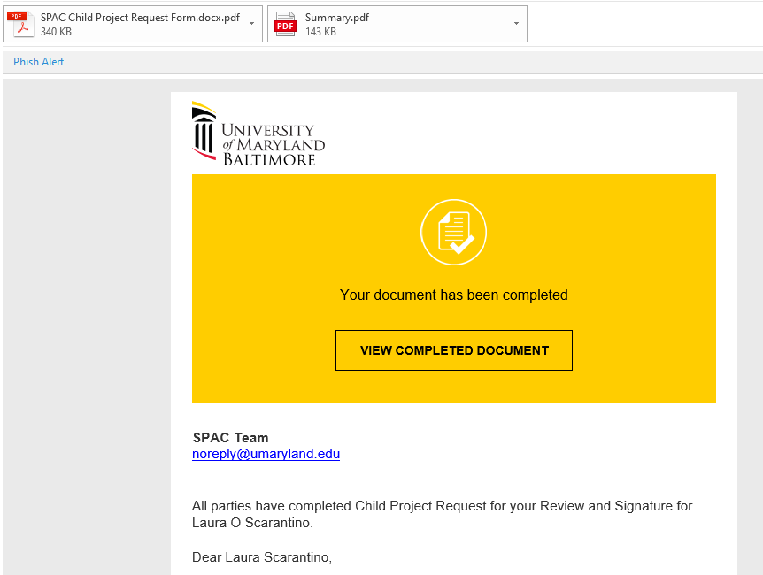
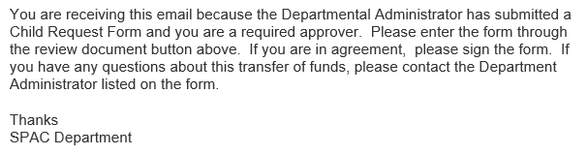

END OF INSTRUCTIONS

