UMB Deposit Form Manual
Link to Deposit form: https://cfapps.umaryland.edu/admin_ﬁn/deposit_form/
- Log In to deposit form via SSO authentication.
Home page will list any Pending Deposit, Work in Progress, Deposited forms.
- Select New to create a new deposit summary form.
- Fill in all department information ﬁelds that are not pre-populated.
If the person completing the form is the contact person for the deposit, select Yes to the following radio button.
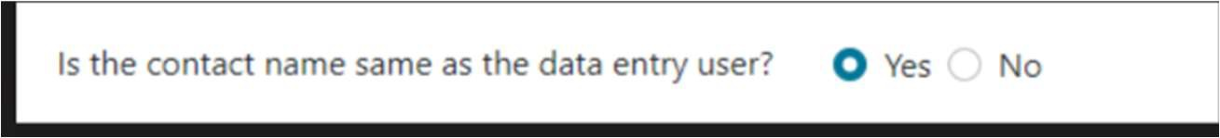
If no, you will need to enter the deposit contact information.
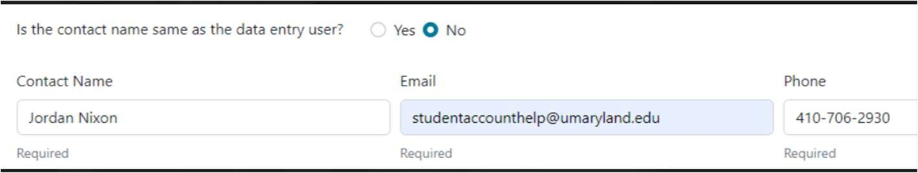

- Under Deposit Information, select Deposit type, “Cash/Check”.
Select from one of the seven diﬀerent deposit types in the dropdown.
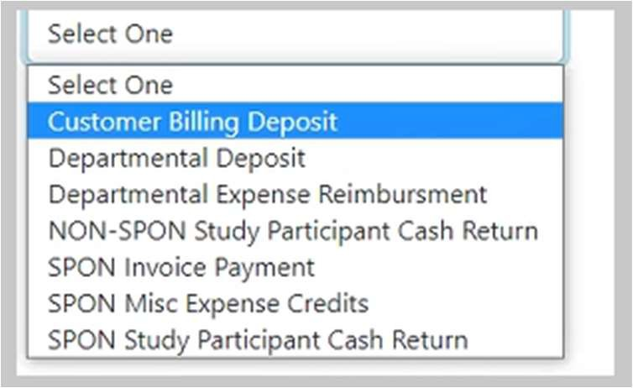

Deposit Type Descriptions:
Please visit the link below for a detailed description of each deposit type.
https://www.umaryland.edu/student-ﬁnancial-services/university-cashier/

  - Customer Billing Deposit: used for a deposit of UMB funds received for a UMB customer billing invoice.
  - Departmental Deposit: used for UMB funds received and deposited to the general ledger. Select this option for funds that are not related to other Deposit Types (i.e., SPON, Customer Billing, etc.).
  - Departmental Expense Reimbursement: used for a deposit of UMB funds reimbursing a non-sponsored expense.

  - NON-SPON Study Participant Cash Return: used for returning undistributed research study participant cash to a non-sponsored source.
  - SPON Invoice Payment: used for a deposit of UMB funds received as a payment of an open sponsored receivable.
  - SPON Misc Expense Credits: used for returning funds from a vendor or sub recipient to the award.
  - SPON Study Participant Cash Return: used for returning undistributed research study participant cash to a sponsored source.

- Select SAVE when done. Any updates or changes that are needed can be done after selecting SAVE, an update button will appear.
- Complete the Deposit Distribution section.
Depending on the deposit type chosen, the Object/SOAPF may auto populate OR you will need to enter the Object/SOAPF information. Fields that auto populate are locked from editing. The deposit form utilizes an approved list of Object/SOAPF combinations. If you receive an error message when entering the Object/SOAPF, email the University Cashier’s oﬃce at universitycashier@umaryland.edu.
- Payment Type – Select from drop down of Check or Cash.
- Amount – Enter the dollar amount.
- Check Maker – Enter the company name or person the check is from.
- Customer Billing Invoice Number/Deposit Description – Enter necessary details about the deposit.
- Add additional lines, if necessary, by choosing the + sign.
- Select Submit when done.
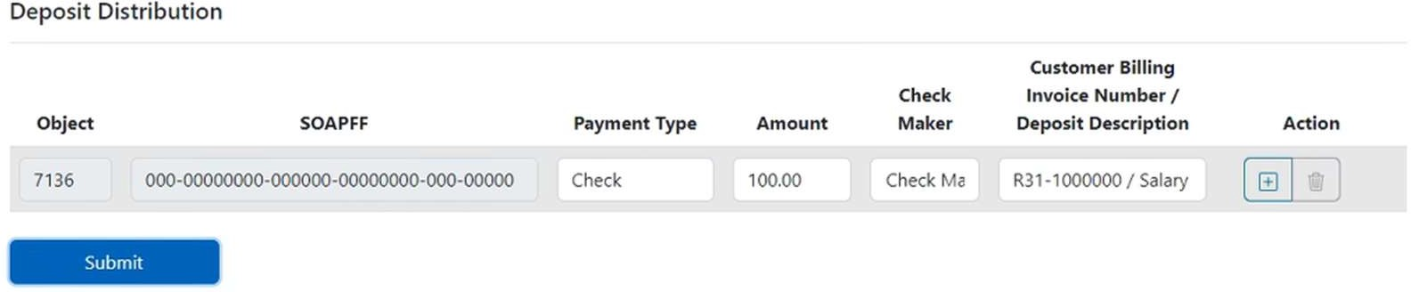

- The message below will appear if deposit form is completed accurately and ready to be processed at the cashier’s oﬃce.
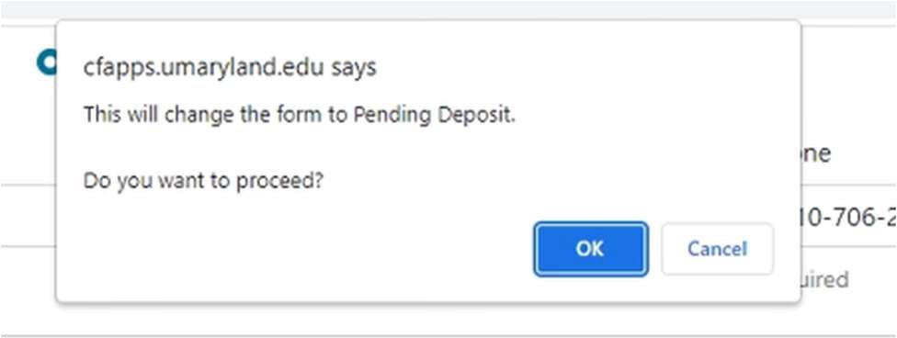

- When you select OK, the following will appear:
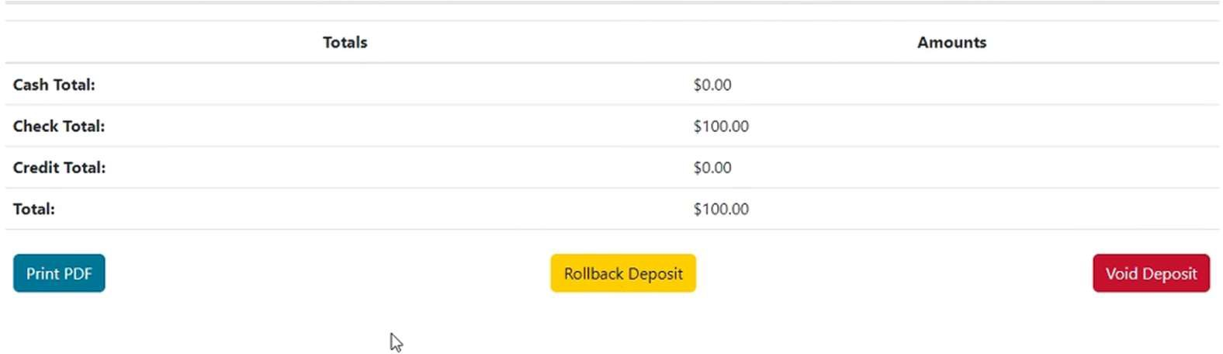

- Rollback Deposit – Select to make changes to the deposit.
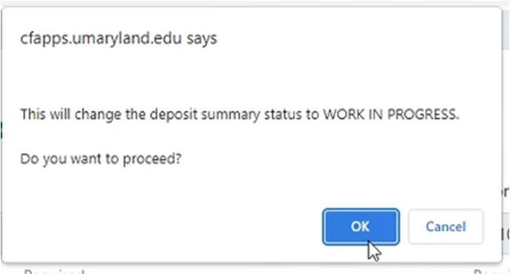
- Void Deposit – Deletes the form completely. Voided forms will not appear in the Home screen.
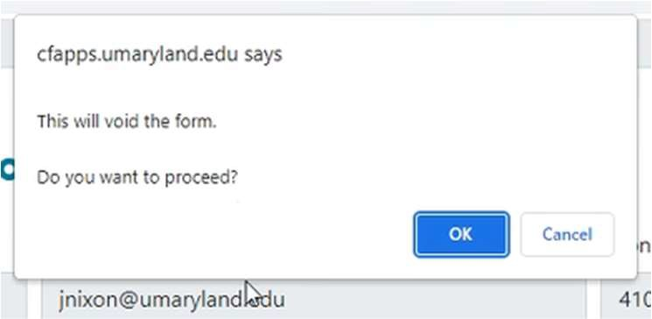

- Print PDF – this will change status to PENDING DEPOSIT. Print the completed form and bring to the cashier’s oﬃce after making an appointment.
  - Link to make an appointment at the cashier’s oﬃce: https://www.umaryland.edu/student-ﬁnancial-services/university-cashier/
- The Home screen will show any forms created for historical record.
Forms will be listed as: Pending Deposit, Work in Progress, or Deposited as below:

