Life After Fetch – Working with Data in Excel

Buzz Merrick, Manager, e-Learning@UMB
University of Maryland, Baltimore
bmerrick@af.umaryland.edu
410-706-1246

Upon completion of this workshop, users will have knowledge of these Excel techniques:
- The way Excel works with database information (page 1)
- Copy Sheets (page 2)
- Freeze Panes, Rename Sheets and using Auto Calculate (page 3)
- Format Your Worksheet (page 4)
- Sorting Data Using Toolbar buttons and Menu Bar (page 5)
- Using AutoFilter (page 6), Creating Custom Filters (page 7)
- Creating Pivot Tables (page 8),
- View Details Easily -the double click on a total feature – (page 11)
- Sample “Layouts” for selected pivot table reports (page 12)
- Edit Pivot Tables (page 14)
- Windows Tips N Tricks (page 15)

Understanding How Excel Works with Database Information
To best utilize these tools, it is important for users to understand how Excel treats information stored in sheet tabs. Excel treats data stored in rows and columns as a database, up to the point that it finds a completely blank row or column. I call this the “automated data selection” feature. This Excel feature saves the user from having to manually select the range of cells that contain information needing analysis. The user then applies Excel’s powerful database features, (probably borrowed from Access!) to the area Excel thinks is the database. Because of this, it is vital to have your cursor clicked on any single cell within the data area before using automated data select.

When users apply the Sort feature, for instance, Excel looks for and selects what it thinks are the boundaries of the database. Get it? The base of the data: the perimeters, the boundaries. Look closely, you will see your data highlighted in black during the sort process. It goes by very quickly. If your data is one contiguous set of uninterrupted rows and columns, Excel will use that as your "base" of information and will relocate each row of data appropriate to the sort order you choose. That's a fancy way of saying that everything about Jane Smith (name, date of birth, admission code, etc.) will make the jump to the appropriate line if you sort on last name, for instance, if there are no blank columns between those fields (column headers). Individual blank cells are OK, just not completely blank rows or columns. If you use blank columns or rows for presentation purposes – get rid of them for data analysis! Making things look pretty is a different workshop!

That is why it is absolutely imperative that users first "clean up" the data that is transferred from any canned report. For instance, if your data looks like it extends from column A through M, but column D is actually empty, Excel's automated data selecting feature will only select the data from columns A through C. If you were to then use the Sort tool, only columns A-C would be sorted, leaving the information from columns E-M unchanged! The information in those columns would not be representative of the information in columns A-C. Basically what you would have is two sets of completely unrelated data. Be very careful of this! This “automated data selection” feature is the basis for Sorts, Filters, Subtotals and Pivot Tables. If you "get" this, you are well on your way to Excel bliss!

Copying Sheets

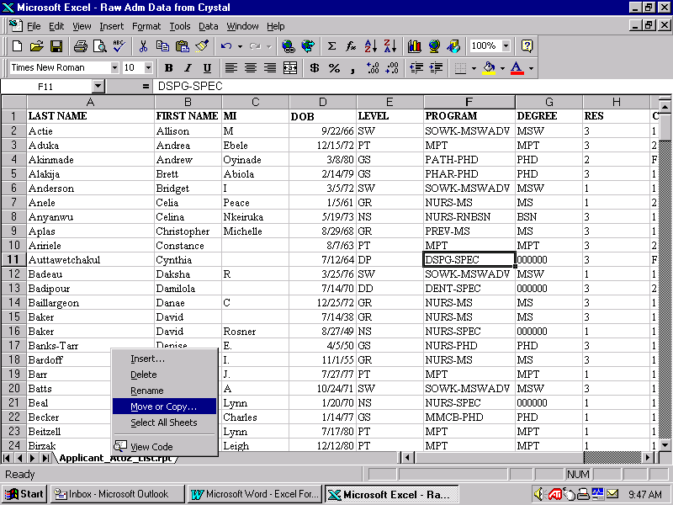
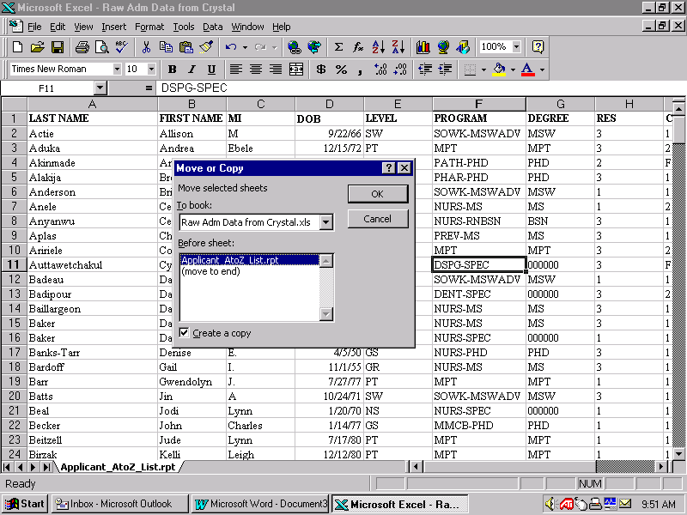
After checking for and deleting any completely blank columns and/or rows, copy the sheet that contains the data. That way you will always have the original to fall back on or copy again. There are a couple of ways to do this. One is to Right Click the sheet tab, as shown below (to open the Quick Menu), and select Move or Copy. Select Create a Copy checkbox from the dialogue box. Then click to tell Excel where in your workbook to put it. You can also use this technique to copy a sheet to a new document or to a workbook (document) you have open!
Right click on the sheet tab
Select Move or Copy
You have to click on Create a Copy and tell it where to live
I always make a copy of the first sheet tab. That way, if I mess it up, I’ve always got my back-up!

Another way is to hold the Control key down while dragging a sheet tab. You will see a plus sign (+) and what looks like a piece of paper. Let go of the mouse before you let go of the Control key! What you lose with this technique is the ability to choose from the list of options the Quick Menu (Right Click) provides. This same technique can be used for copying individual cells, groups of cells, or drawing objects (circles, text boxes, etc.). It is the same technique used in PowerPoint to copy drawing objects (circles, squares, etc.).

Freeze Panes

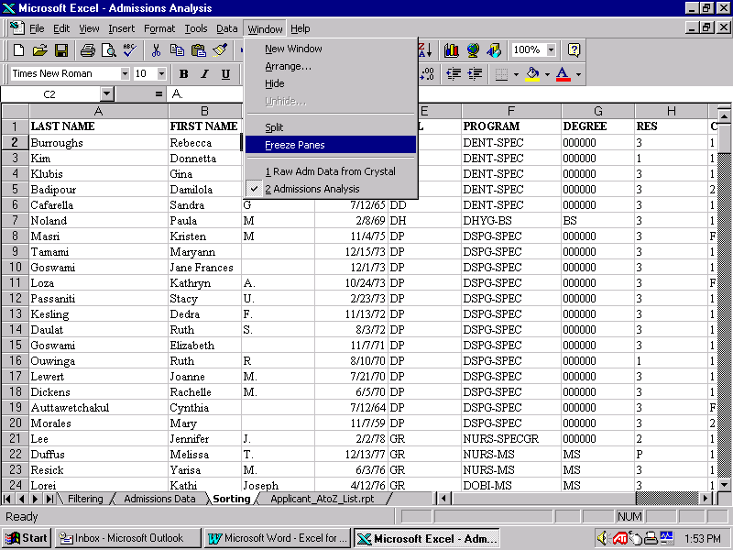
Sometimes, not all the data you want to look at can be viewed at the same time. Freezing Panes is a technique that allows users to "freeze" certain columns and rows to allow one to scroll to other areas of the sheet without losing site of the columns or rows desired.

To Freeze Panes, click in the cell below and to the right of the columns and rows you wish to keep in view (cell C2 in the example above). Then click on Window, Freeze Panes and Excel will keep the rows above and columns to the left in view. To Unfreeze Panes, simply click on Window in the Menu Bar and select Unfreeze Panes from the list.

Renaming Sheets

I recommend that users rename the copy by double clicking the sheet tab, then type the new name and Press the Enter key to have the new name appear. Use this copy to perform any of the techniques described in this workshop. Then, if you want to use another of the tools, copy the original again, rename it, and use that tool. This way, each tool used has a dedicated working copy of the information. This will be especially helpful when you wish to chart subtotals. Another way to copy a sheet tab is to Right Click the sheet tab (opens the Quick Menu) and select Rename from the list. Type the new name and hit Enter.

Auto Calculate

The Auto Calculate tool is really neat. Try highlighting a few cells that contain numbers. Now, observe the lower right side of the status bar. Right Click on blank area (or the number displayed and choose Average, Count, SUM, etc. The operator you select will stay in the Auto Calculate area. Highlight other cells to see the calculation change in the Auto Calculate area.

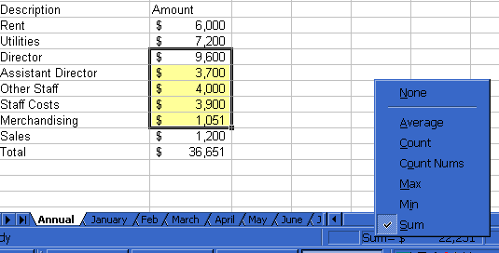
Status Bar
Handy Tip!
Use the Control + Click technique to calculate nonadjacent cells!

Format Your Worksheet
After you have downloaded and made a copy of your data extract from RAVEN, a good “next Step” is to format your worksheet.

Some examples are:
- Expand the column widths to accommodate data
- Change the number “format” to include red and parenthesis for negative values - (5340.00)
- Use the Select All button to change column widths quickly and easily (Auto Resize feature)
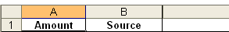
Click the Select All button.
Select All
Place your cursor in between A&B and double lick – this will auto-size all columns to accommodate the data in every column!

2. Select Column A (or individual cells), click on Format, Cells (in the Menu Bar), change the numeric format as shown.
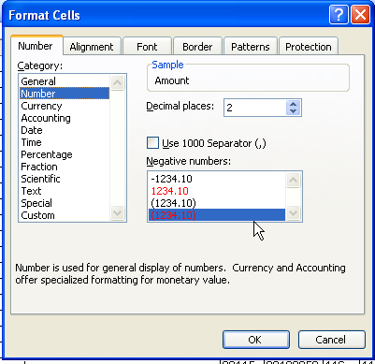
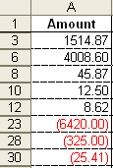
The Result

Sorting Data Using Toolbar Buttons

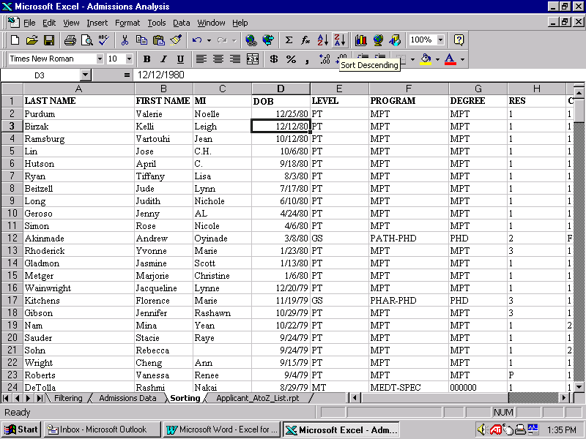
Sorting data is very simple. Click on a single cell in the column you want the information sorted by, then click one of the two Sort toolbar buttons as shown below (ascending or descending). In the example, a descending sort was applied to date of birth (DOB).

Sorting Data Using the Menu Bar

The Sort Menu Bar allows you to apply more than one sort at the same time, up to three (3) levels. It also assumes that the first row of your data is a "header row" - the names of the fields or columns of your data.

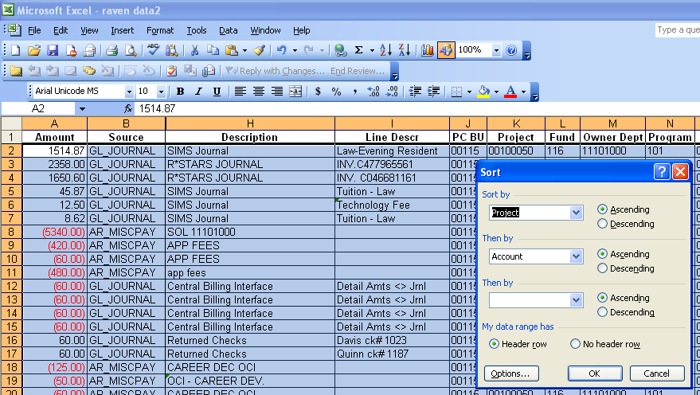
To use the Sort Menu Bar, simply click in a single cell in your data area, then click on Data, Sort from the Menu Bar. When the Sort dialogue box appears, choose the column name for each column (header) desired and whether it should be sorted in ascending or descending order. Note that Excel defaults to your data having a header row and you have the option to change it.

This screenshot above is a good example of how Excel selects the data area for you. Notice that the first row is not selected - that's because it is considered a header row and will not be sorted with the rest of the rows.

If you want to sort more than three, here’s a tip: write out the columns you wish to sort – left to right (on a sheet of paper). Then sort the fields, 3 at a time, right to left!

Using AutoFilter

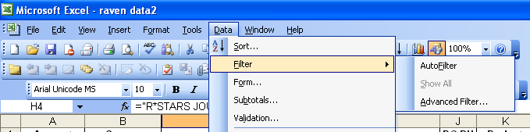
AutoFilter is by far the coolest, easiest-to-learn and easiest-to-use tool in Excel’s toolbox! It works just like the Sort tool. Excel "searches" your database for the perimeters or boundaries of your data and assumes that the first row refers to the names of your data elements, fields, or columns. Simply click on a single cell in your data area, and then click on Data, Filter, AutoFilter. Use this same command to turn off AutoFilter. The checkmark indicates whether AutoFilter is on or off

Excel will place down-pointing arrows in each of your column headers, allowing you to click the arrow and get a "pick list" of the data found in that column. When you click on one of the values in the list, Excel displays only rows that have that value in that column, “hiding” all other rows from view. The down arrow for a column’s pick list will turn blue where the filter has been applied – that way you know which column you’ve filtered on. You can filter on multiple columns. The Status Bar (at the bottom left of the screen, below the sheet tabs) will indicate the number of records selected (e.g., 12 of 265 records found). This is great if all you need is an answer! And the best part about this is what you see is what you print! To get the original data back, click the down arrow and select All from the pick list, or choose Data, Filter, Show All from the Menu Bar. Try it! You’re gonna like the way you look…
Make sure there is a blank row above your column headings row, if your data doesn’t begin on row 1. If you need a title row, insert a completely blank row right above the headings.

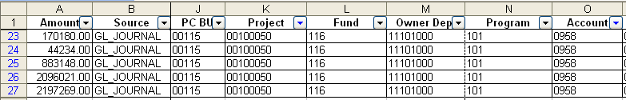
Below is showing where the AutoFilter was applied to columns K and O - Project and Account.

The arrows for Project and Account turn blue – indicating that the AutoFilter has been applied to those columns.

Creating Custom Filters

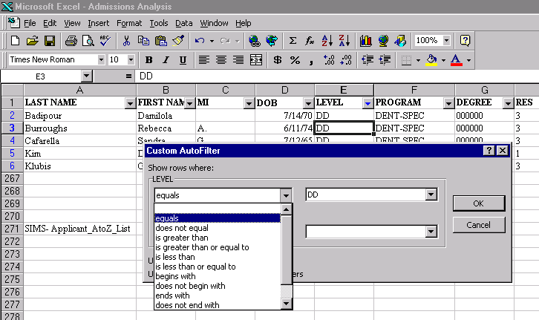
Custom Filters allow you to do some nifty things! You can get data for two departments, or tell it to display only rows that meet a certain date or numeric range (or criteria). To create a Custom Filter, apply AutoFilter first, then simply click the down arrow for the column you want a custom filter for and choose Custom from the list. The Custom AutoFilter dialogue box will appear providing you choices for the type of operator you want (equal to, less than, etc.) and the value you wish to filter on (DD, LW, etc.) from the “pick list” for that column. Pick and Click OK.
You can choose from several operators.

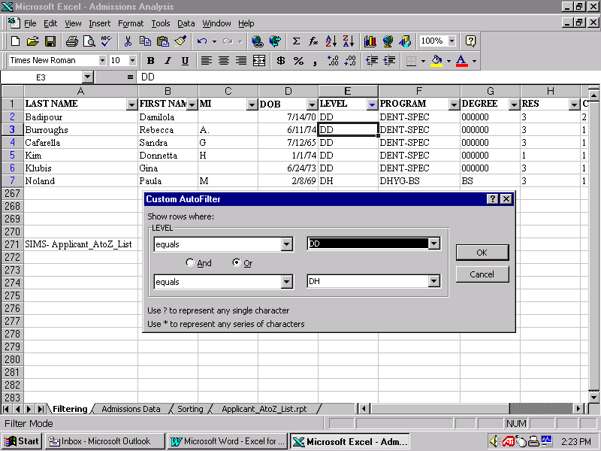
As you can see below you can create an and/or statement by choosing "and" or "or". This will enable you to filter on two different values within the same column. Pick and click OK.

Creating Pivot Tables
Pivot Tables in Excel are used to provide users with a “cross-tab” result – effectively summarizing data while allowing users to expand or collapse detail easily. Like charts, there is an “umbilical cord” between the data and the table, so any changes made to the data will affect the table – only NOT simultaneously! Users must refresh the data in the Pivot Table anytime changes are made in the data sheet. However, if you are using your data as a snapshot you will not be changing the data in Excel, but in the database the data was extracted from.

To create a Pivot Table:

- Make a copy of the datasheet (recommended, not required). Name it “Pivot Data”, so you’ll know this was the sheet used for the Pivot Table.
- Click on Data, Pivot Table Report from the Menu Bar (this will open the Pivot Wizard).
- Indicate that the data comes from Excel and click Next (Step 1).
- Verify the range of data used for the table and click Next (Step 2).
- Click on the Layout button (Step 3) to construct your Pivot Table by dragging and dropping fields to the appropriate area of the wizard diagram and click Next.
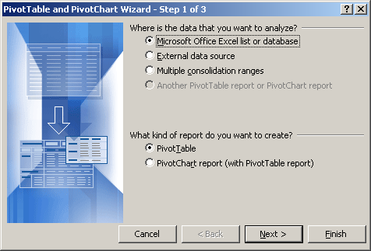
- Choose whether to locate the Pivot Table in a new worksheet or as a new workbook (document) and click Finish (Step ).
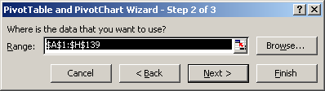

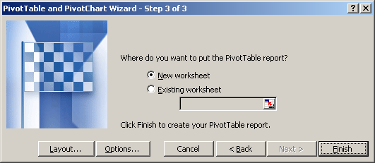

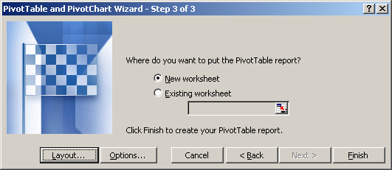
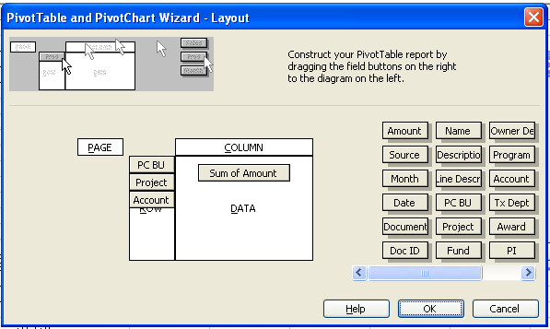
Double Click here to change format (e.g., number format with red and parenthesis)
The Result

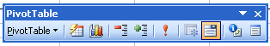
A new sheet tab is created with the pivot table in it. The data in the pivot table has an “umbilical cord” to the data sheet you started with. If you change the data in the original, you can “refresh” the pivot table, using the ! (exclamation mark) tool in the Pivot Table toolbar.

Drop down arrows in the pivot table allow you to view or hide groups of data. Sorting is from left to right (columns A-Z). You can also sot within columns (for instance salary), descending or ascending.

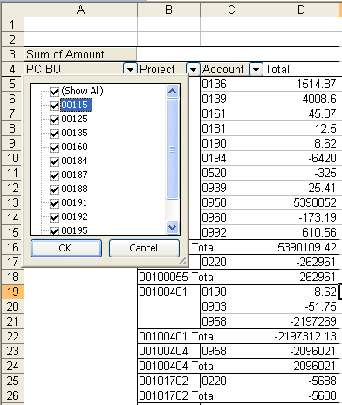

View Details Easily (the double click on a total feature)
If you are interested in seeing the details for one of the subtotals displayed, simply double click the number )as shown below). Excel will go to the sheet tab with the data and extract the details (the rows) that make up the subtotal, insert a new sheet tab and copy the results into the new sheet tab, along with the header row (so you will know what the names of the columns are).
Double click on a number in the total column to open a new sheet with the details!, as shown below. It will include the header info.

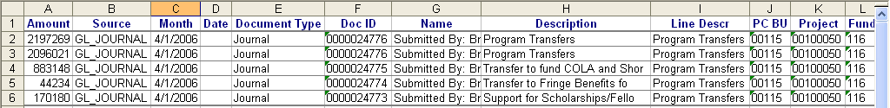
The Result

Sample “Layouts” for selected pivot table reports:
Add Source to the Page area to get this
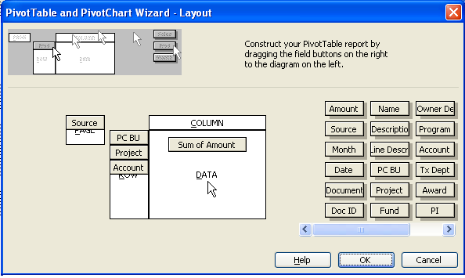
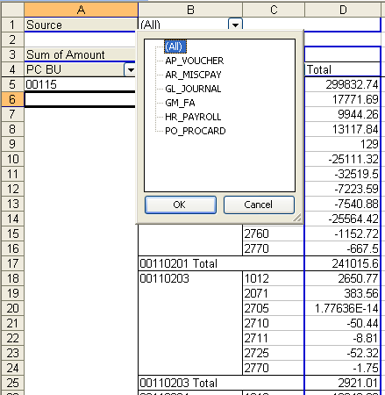
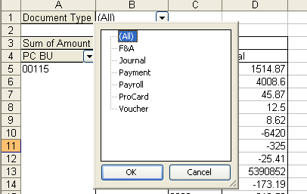
You can use the field Document Type in place of Source on the Page area

Using the Drop Down Arrows in a Pivot Table
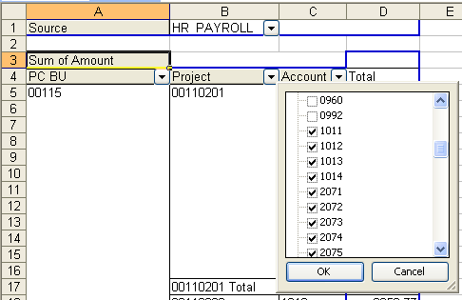
You can choose to “filter” your pivot results by using the drop down arrows for the fields in the table. Deselecting the “Select All” choice allows you to scroll through the data and select individual totals to view.

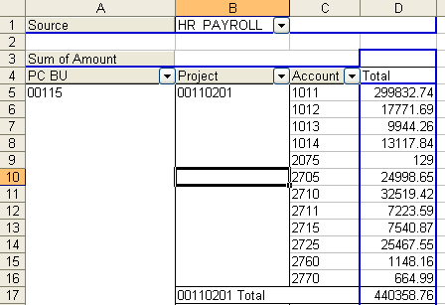

Edit Pivot Tables
There are two ways to modify a Pivot Tables. The simplest way is to click in the table to activate the Pivot Table, the Toolbar, and display a field list. Then, just drag fields from the toolbar to the table. Be careful, you must visually confirm where you are going to drop the fields - look for a fuzzy line with brackets as your guide. The second way is to click somewhere in the Pivot table, then access the Layout feature from the Pivot Table Toolbar button as shown below.

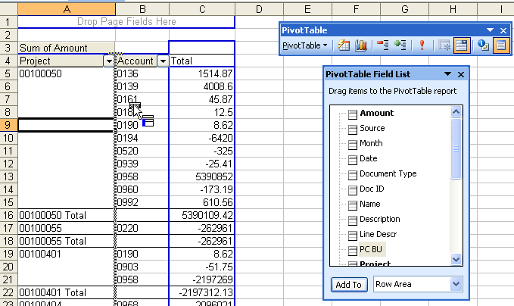
The first way:

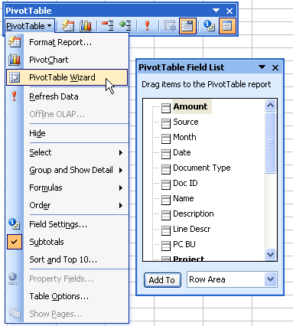
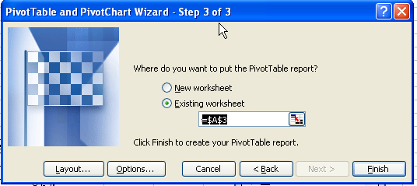
The second way (recommended): use the toolbar to return to the Wizard
Windows Tips and Tricks

- As a general rule: type it first, spell check it, save it and then make it look pretty!
- Windows loves selections: When you select something in Windows, you tell the computer to ignore everything except that which is selected. You select something and then do something to that which is selected. This works in Word, Excel, PowerPoint, Outlook. Excel’s auto select feature enables filters, sorts, pivot tables, etc.!
- So, select the information and then apply the trick/technique (copy, format, etc.)
- In Word, use the formatting toolbar, the ruler and the show/hide toolbar button as a substitute for Reveal Codes (for those suffering from Reveal Codes Withdrawal).

Shortcut key techniques:
Control + C, X, or V | Copy, Cut, Paste a selection
F4 | Repeat last action
Control + A | Select All (in a document)
Click + Shift/Click | To select a range (Excel, Word & Outlook)
Shift + Arrow keys | To increase or decrease a selected area (range)
Control + Click  Control + Click/drag | To select non-adjacent cells or a range of non-adjacent cells
Alt + Enter | Insert a line within a cell in Excel
Control + P | To open the print dialogue box
Control + F | To open the Find dialogue box – this works on the Internet
Control + S | Save a document (Quick Save)
Control + “ (quote) | Copies the data from the cell above (Excel and Access)
Control + Arrow Keys | Move a drawing object (nudge)
Control + Delete | To delete the word in front of the cursor
Control + Backspace | To delete the word in back of the cursor
Control + F4 | To close a document
Control + F6 | Toggle between open documents
Control + Home | Go to the top of the document
Control + End | Go to the bottom of the document
F7 | Start Spellchecker
Double click gray area of ruler in Word | Opens Page Setup Dialog box
Alt + Tab | Toggle between open applications
Double click a total in a Pivot Table | Displays the details from a data sheet tab in a Excel generated separate sheet tab (includes header info)

