Guidelines for Completing the Introduction to the eUMB HRMS curriculum
- Log into the UMB Learning Management System (LMS): https://umb.sumtotal.host/

- Click on the Library Icon from the top blue bar, navigate to the Introduction to the eUMB HRMS Curriculum:
LIBRARY (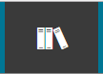) > UNIVERSITY OF MARYLAND BALTIMORE (UMB) > INTRODUCTION TO THE eUMB HRMS > SELECT > REGISTER

- The LMS displays the two required activities. Click the “REGISTER” button on the bottom of page

- Each activity is now displayed. The activities must be completed in sequence. The first activity is Guided Tour of the eUMB HRMS. Click START.

- The Learning Activity Details description window will appear. Click the “Next” button

- There are 5 chapters in the Introduction to the eUMB HRMS curriculum. The first chapter “Concept” is the description of the course. When you go through the rest of the required 4 chapters, we recommend you to print out the Job Aid by clicking the “Print It” button on the top of the blue bar.
- After printing the Job Aid, you may start the tutorial:
  - Whenever the screen displays a Try It! Prompt (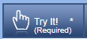) in the upper left hand corner, you must complete the step.
      - Click Try It!
      - Proceed through the tutorial.
      - After completing the steps, click the arrow at the top of the screen to advance to the next chapter.
      - All chapters listed in the menu on the sidebar must be completed.

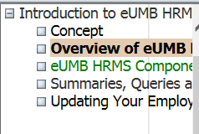

  - After you have finished all the chapters click the X in the upper right hand corner of the tutorial screen to close the window:

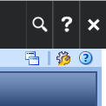

  - You should be at the LEARNING ACTIVITY PROGESS DETAIL screen showing that you have successfully completed the 4 Chapters:

- After completing the GUIDED TOUR of the eUMB HRMS, you will be prompted to click OK and you should be returned to the main page (i.e. TRAINING SCHEDULE) where you can START the QUICK ASSESSMENT/Introduction to eUMB HRMS Quiz:
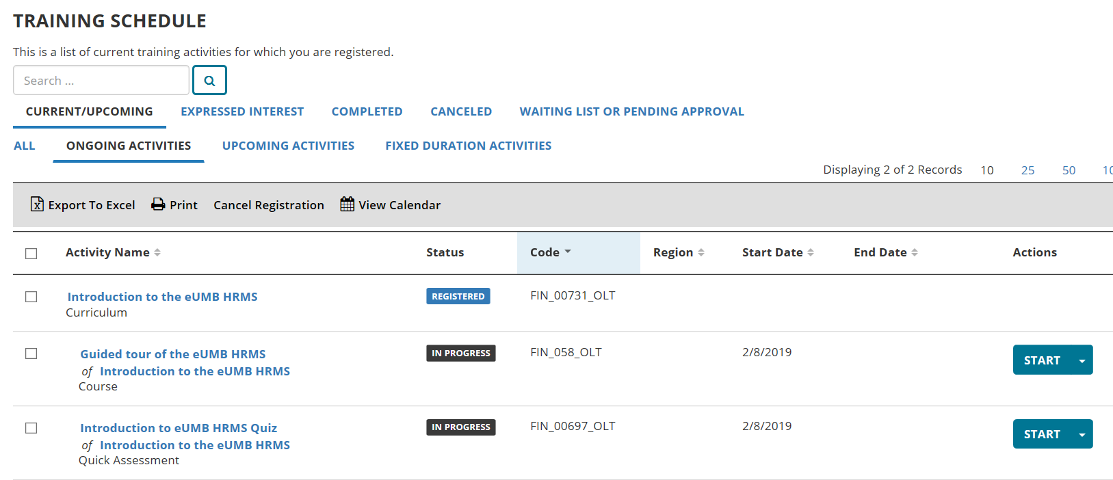

  - Begin Quick Assessment/Introduction to eUMB HRMS Quiz.
  - Click on the link: Introduction to eUMB HRMS Quiz.
  - Click “Start” to start the Quiz.
  - After you answer the last question click SUBMIT ASSESSMENT.
  - The LMS will display feedback. If you would like to review each question, click GO TO REVIEW. Otherwise, click CLOSE. (Note that the questions are displayed in reverse order in the review process. Click PREVIOUS to scroll through all of the questions).
  - You must pass the assessment. If you do not pass the assessment you may retake:
    - Click REVIEW and scroll through to determine which questions were answered incorrectly.
    - Click CLOSE.
    - Click OK (see below). You should be directed to the TRAINING SCHEDULE page.
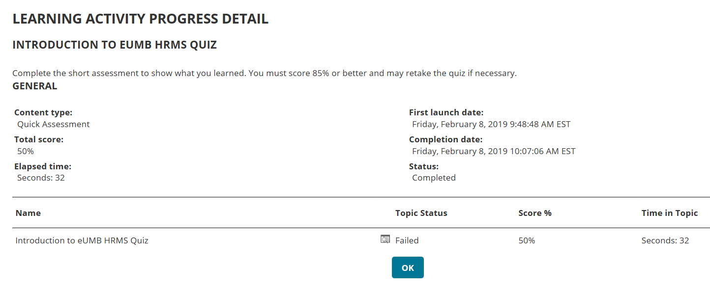

  - Print the diploma for your own record!
    - Go to Home by clicking the following UMB Icon in the middle of the top blue bar :

    - Select Training Transcript.
    - Locate Curriculum: Introduction to the eUMB HRMS
    - Click the diploma icon:
    - You can either select PRINT or EXPORT TO PDF.
      - PRINT – Prints in a page view format
      - EXPORT TO PDF – Prints as a presentable document
        - Click File.
        - Print.
        - Close window.
        - Click OK.
        - Click CLOSE.
- You may now register for the Commitment Accounting (CA) and/or Departmental Payroll Processing (DPP) courses if required by your department.
- Complete the online CITS Access Request Form if you are requesting any eUMB HRMS role.

