Misc Topics

Security & Role Validation
Department heads (Chairs, Directors, Administrators) have control over who has access to their HRMS data and what type of HRMS data each user has by approving the "eUMB HRMS User Authorization Form and System Access Agreement" form. It is a good idea to periodically validate who is accessing your department's data especially when there is staff turnover.

This UPK demonstrates the on-line pages where HRMS users with the UMB_DEPT_HR_REP or UMB_DEPT_ADMIN role can validate this information. There is a page named UMB User Security and another named UMB Role/Dept Security.

Procedure

In this UPK, you will be looking to see who in your department has any HRMS role, what specific roles they have, and then who else outside your department may have access.

Step | Action
 | You are logged in as a ficticious Program Administrator for a ficticious School of Medicine department- 10211000- SOM Research.
The new pages have been added under a new menu group called UMB Utilities. You will begin by navigating to the UMB User Security page.

From the Main Menu, click the UMB Utilities link.
 | Click the UMB Utilities link.
 | Click the Inquire link.

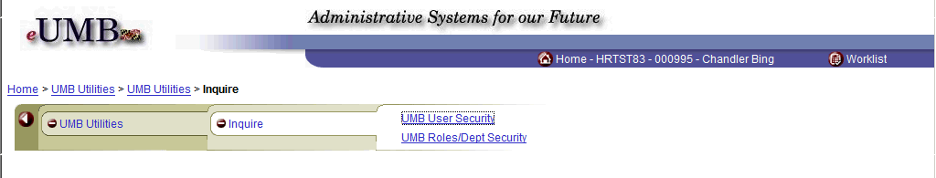

Step | Action
Both new pages appear in this group.

Click the UMB User Security link.

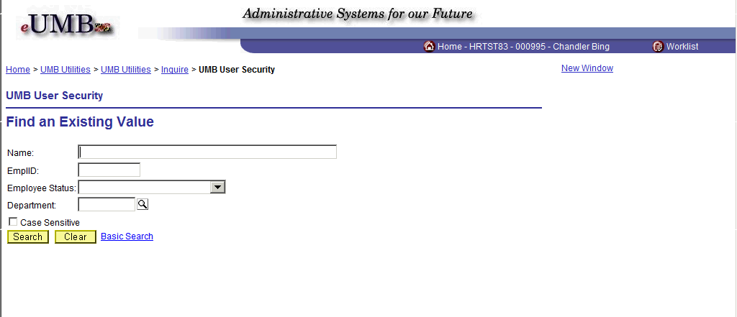

Step | Action
 | There are several parameters that can be used on this search page. Which ones you choose to use will depend on what information you are looking for and how many departments you have access to.
 | If you are interested in finding out which roles and departments a specific employee has access to then you will use the Name or EmplID fields
You can search for employees based on a specific Employee Status.

Click the Drop-down arrow.
 | If you have a large department with a lot of turnover you may want to choose the Active status to filter out the employees who no longer work at UMB.
You must enter some criteria on this page. However, you can use a "wildcard" character which is the percent sign (%) in eUMB to retrieve everything you have the right to see.

In this example you have a small department and you want to see everyone in your department who has at least one role in HRMS. Enter the wildcard character into the Department field.

Enter "%".
 | Click the Search button.

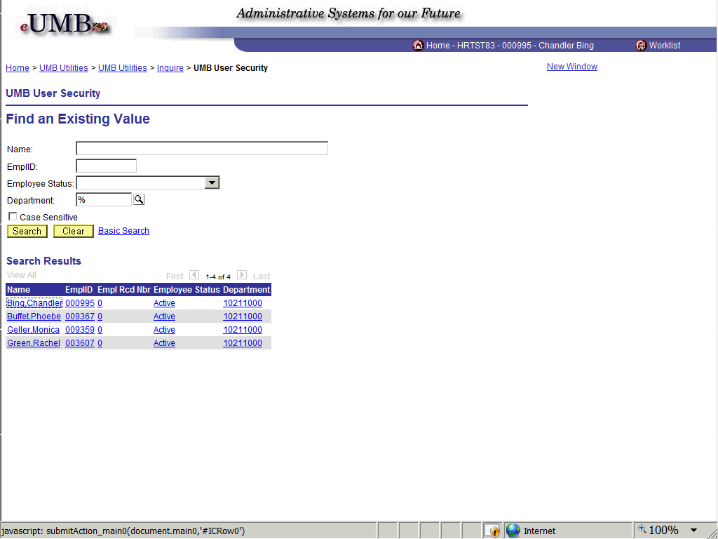

Step | Action
Your Search Results have returned the 4 employees in your department who have at least one role.

To see the details of the roles and department access each person has, you must select each person from the list.

In this example you are going to start by looking at your own security.

Click on any of the links on the row for Chandler Bing in the Search Results table.

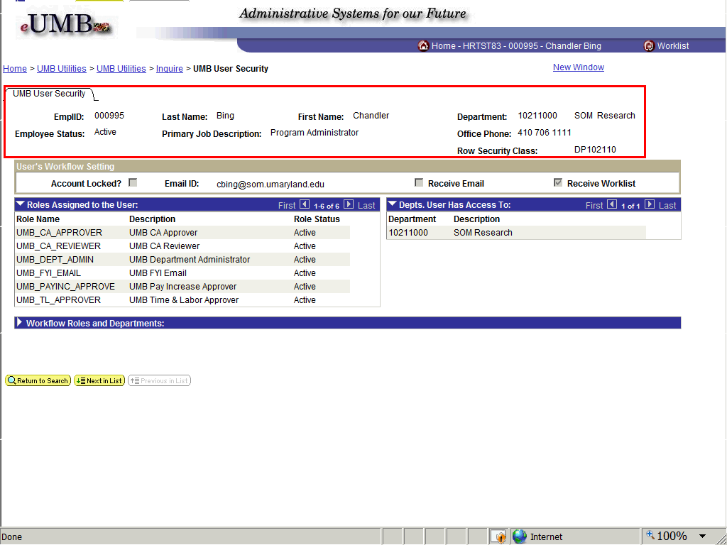

Step | Action
You are looking at the details page for this one employee.

In the header section you are given some additional information such as the Employee Status, Job Title, and Phone. The Row Security Class is a code that CITS uses to assign the specific departments to a user.
The User's Workflow Setting section has important information if the user has one of the Commitment Accounting (CA) roles where "Workflow"- the electronic approval routing process- is used.

If you have a user with a CA_Approver role who is not getting e-mails about EFPs that have been entered then you can check this page to make sure the e-mail address is correct.
 | The Roles Assigned to the User section details out the specific roles the user has and whether the role is Active.
 | The Depts. User Has Access To section details out each department that a user is allowed to see. For users in the Dean's Office at a school this list can be long.
 | Click the Expand section button for the Workflow Roles and Departments section.

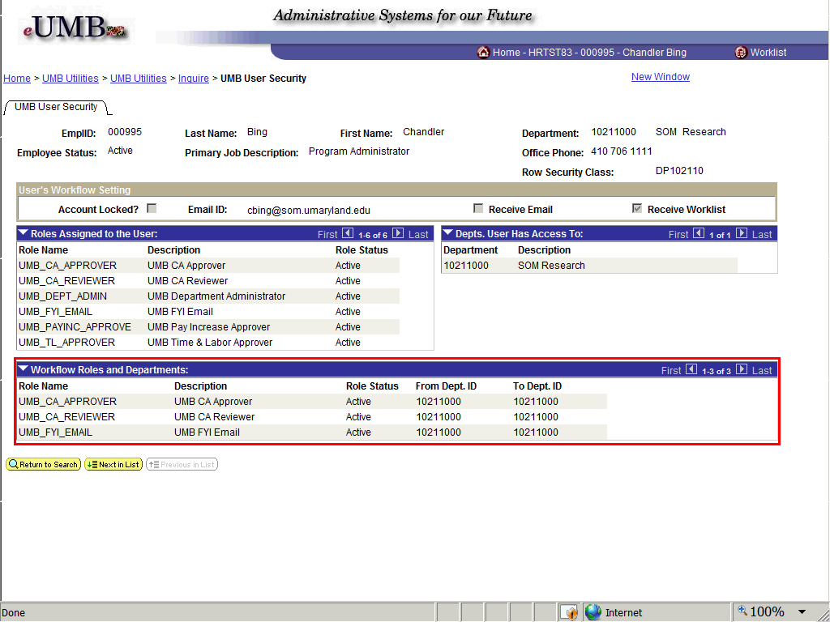

Step | Action
For each of the CA roles that have workflow, the specific departments associated with each row are identified.

If the user has many CA roles and many departments then this list can also be very long.
Now you want to look at the next employee in your department from the Search Results page.

Click the Next in list button.

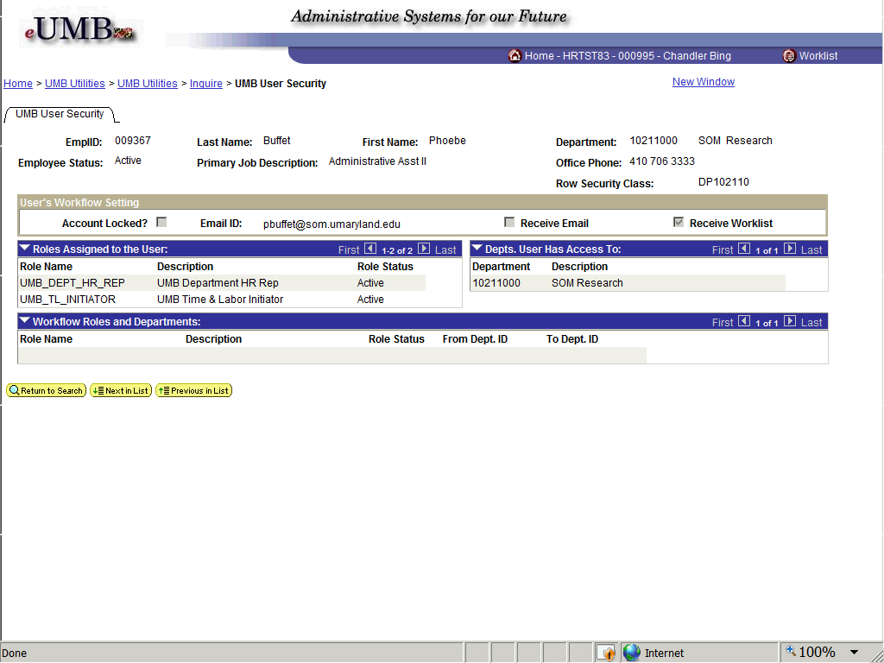

Step | Action
 | You can see that this employee only has two roles and neither is a CA role so there is no information in the Workflow Roles and Departments section.
You don't want to look at everyone but you do want to look at the last person on the list.

Click the Return to Search button.
 | Click on any of the links in Rachel Green's row from the Search Results table.

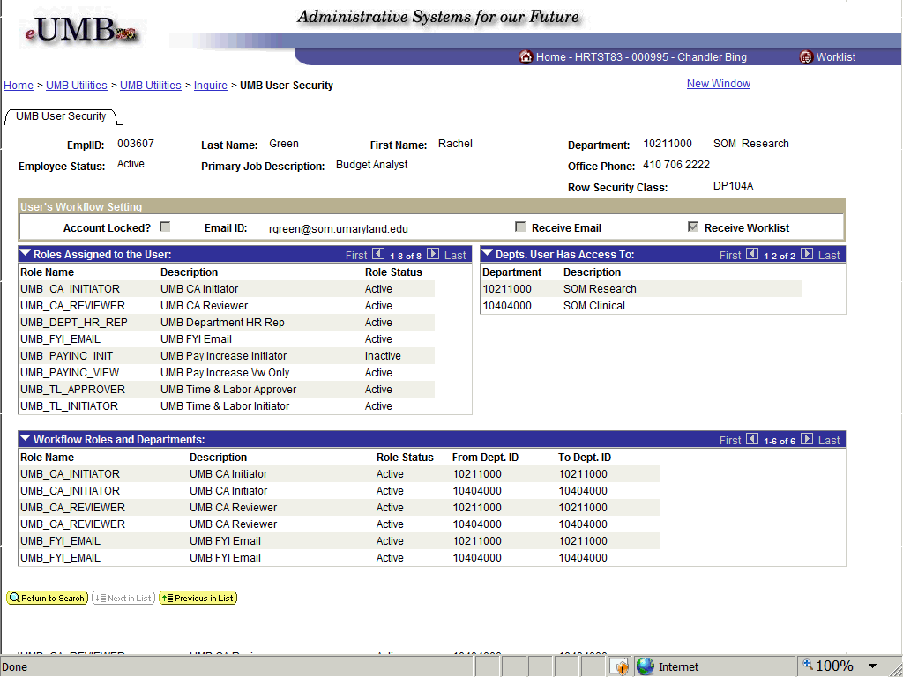

Step | Action
 | This is an example where the user has access to more than one department. In this case the user is still doing work for her former department- 10404000. Both departments are listed in the Depts. User Has Access To section.
You can also see that each department is specified for for each CA role the user has in the Workflow Roles and Departments section.

As the Administrator you can start troubleshooting here if you have a user who cannot enter an EFP for a particular employee. You may find that the user doesn't have access to the department that owns the employee.
This concludes the demonstration of the UMB User Security page.

Click the Inquire link in the breadcrumbs to look at the UMB Roles/Dept Security page.
 | Click the UMB Roles/Dept Security link.

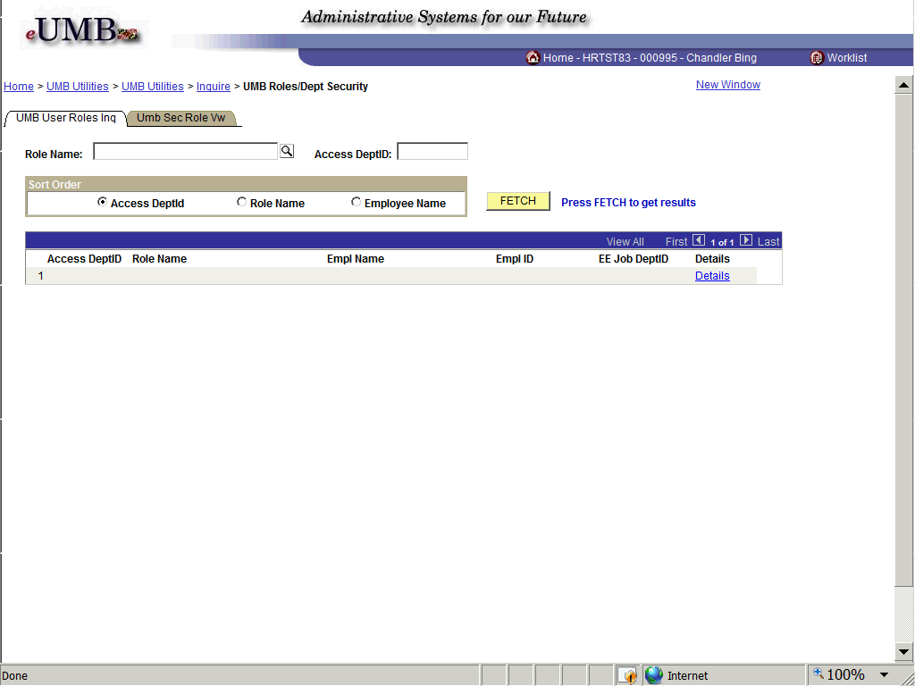

Step | Action
 | This page allows you to search for employees who have a particular role and/or access to a particular department for those users with access to many departments.
In this scenario you want to know how many other people have the CA_APPROVER role to make sure you have a backup.

Click the Lookup Role Name button.

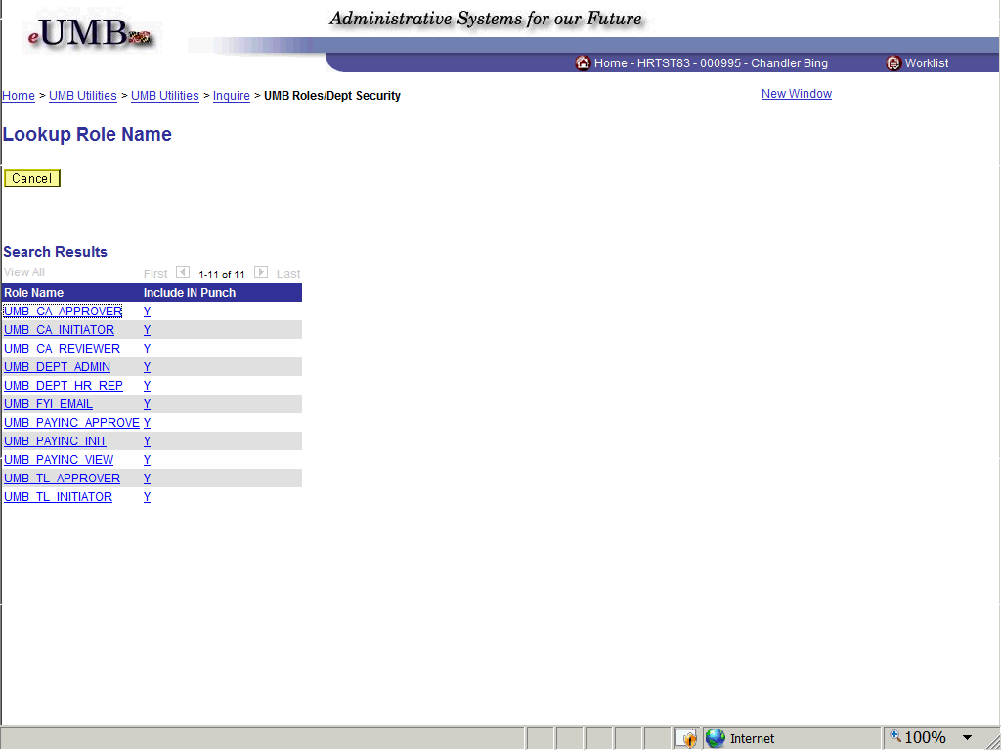

Step | Action
This is a list of all the department user roles that you can search on.

Click the UMB_CA_APPROVER link in the Search Results table.

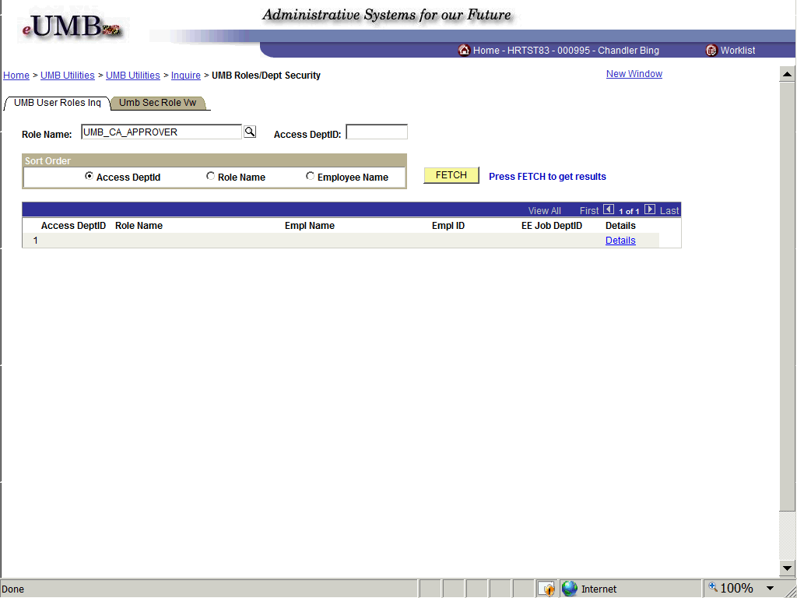

Step | Action
In the Sort Order section, you can choose your sort option which becomes more useful when you expect a large number of results.

You'd like to see the list sorted by name so click the Employee Name option.
 | Click the FETCH button which is similar to the Search button used on other pages in eUMB.

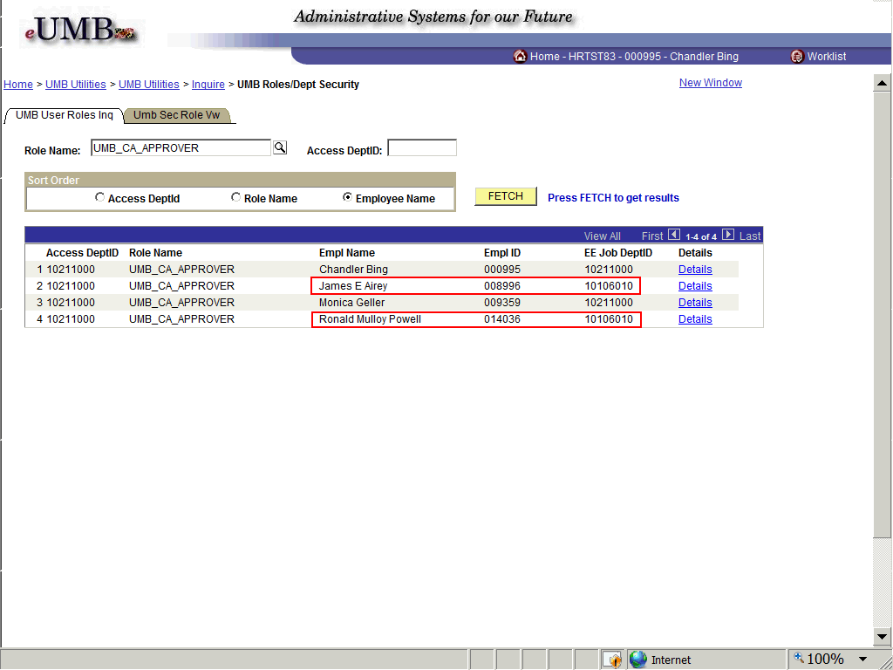

Step | Action
 | In addition to the two employees in your own department who have the CA_APPROVER role, you find there are two employees in the SOM Dean's Office who also have this role with access to your department.
This time you want to see everyone with either the T&L Initiator or T&L Approver role. Since they both begin with UMB_TL you can use the wildcard character.

Click in the Role Name field to highlight the CA_APPROVER text to overwrite it.
Type in part of the role name in the Role Name field and use the wildcard character.

Enter "TL%".
Since you will be retrieving multiple roles you want to sort it by the role name.

Select the Role Name Sort Order option.
 | Click the FETCH button.

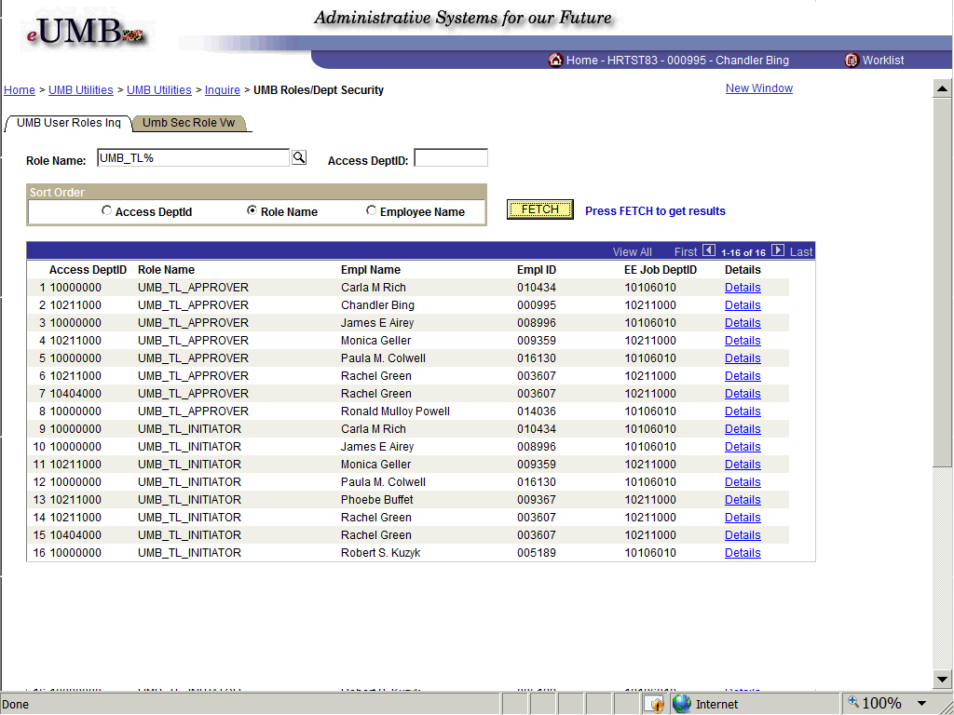

Step | Action
 | You see everyone who has the either the T&L Approver or Initiator role for your department including those users from the Dean's Office.
 | If you want to view the specific access for any of these employees you can click the Details link.

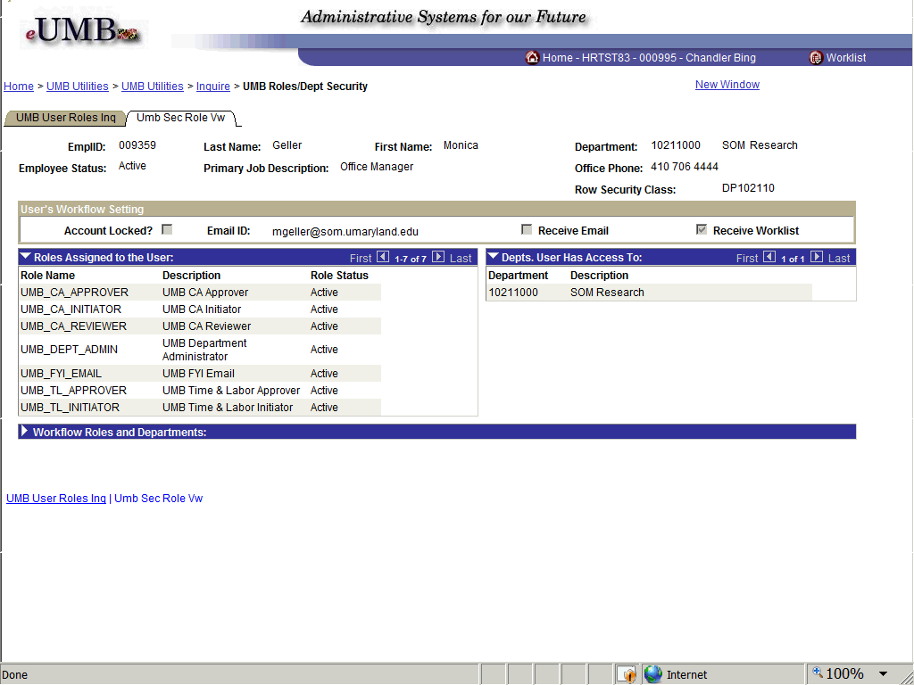

Step | Action
 | This brings you to the page you accessed earlier when you searched via the UMB User Security link.
 | To return to the search results click the UMB User Roles Inq tab.
Now you want to see everyone who has any role with access to your department. You start by clearing the Role Name field.

Highlight what was previously entered and press the [Delete] key.
 | Click in the Access DeptID field.
Enter your department ID into the Access DeptID field.

Enter "10211000".
 | Click the FETCH button.

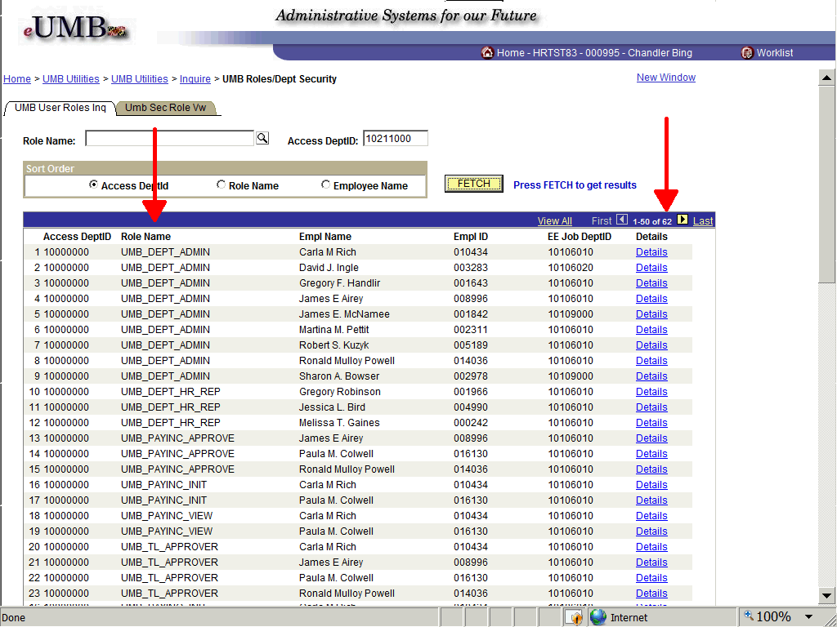

Step | Action
 | Note that you have 62 rows and a number of different Role Names listed. This list is sorted by the Access DeptID so all of the SOM Dean's Office users are listed first.
Return to the menu items.

Click the Inquire link in the breadcrumbs.
If you have any questions about the security roles, access departments, or workflow departments for employees in your department, you should contact the ASC Help Desk at 6-HELP(4357) or e-mail Help@umaryland.edu

If you need to make changes to an employee's user access you must complete the appropriate form found on the CITS website:

http://www.umaryland.edu/eumb/security
End of Procedure.

