Office of the Controller Job Aid
Responsible Unit | Student Financials | 03/21/2023
Title | Departmental Deposits

UMB Cash Handling Procedure requires UMB cash/checks to be brought to the Cashier’s Office within 24 hours of receipt, or the next business day.

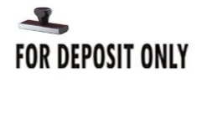
- Upon opening and logging checks for deposit, immediately endorse the check with the Wells Fargo Depository Stamp.

- Complete Online Deposit Form and print the completed PDF form.
  - Instructions for Departmental Deposits, Expense Reimbursements, Sponsored Projects (SPAC) and Return of Undistributed Research Study Participant Cash can be found at https://www.umaryland.edu/student-financial-services/university-cashier/.

- Schedule an appointment at University Cashier Microsoft Bookings.

- At the time of your appointment, please bring the completed deposit form, cash/checks and any additional backup required for SPAC or Customer Billing deposits.
  - All departments must wait for a receipt.

- UMB departments are required to reconcile cash/checks deposited at the University Cashier’s Office to Quantum.

