Office of the Controller Job Aid
Responsible Unit | Payroll | June 26, 2023
Title | Review Form W-4

- This form is required to be typed, printed, and with wet signature in black ink. All hand-written form will be returned by Central Payroll Bureau, State of Maryland (CPB).
- CPB takes about 2 pay periods to process this form.
- Employees are encouraged to complete a new form if changes have not been made after 2 pay periods. It is possible the form is being returned by CPB.

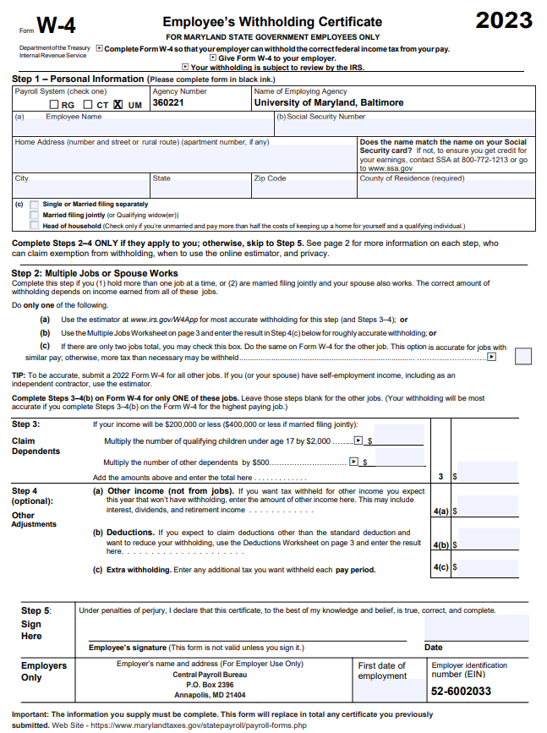

CPB uses Form W-4 for (1) Tax withholding purposes and (2) Change of Address. An original form with wet signature is required for new employees. Completed Form W-4 will be sent to CPB for processing after review. OOTC-Payroll Services and Human Resources do not keep copies of this form. Employees who filed ‘Exempt’ from federal withholding must file a new form and submit it by February 15 of each year.
Form W-4 for foreign national employees must be sent with their Glacier packet.
CPB has not processed your Form W-4 if your paper paycheck or Check Advice:
- Do not show your address.
- Marital status, exempt information, and County code show different information than the Form W4 you completed.
- Employees may need to re-submit a new Form W-4 if the information is not appearing on paycheck for more than 2 pay periods.
- Late submission will result in maximum tax withheld. Employee must file taxes at the end of the year to claim tax refund because CPB will not issue tax refund.
Form W-4 can be found at: Employee's Withholding Certificate (Federal & State) - Payroll Services (umaryland.edu)
New Employees
- Complete the online Form W-4 as the required university information have been prefilled. After completion, print, and sign it with black ink.
- Completed form to be submitted at Onboarding.
- If the form was not submitted during Onboarding, submit it to the department payroll rep.
Current Employees
- Submit changes via the State Payroll Online Service Center (POSC) at Payroll Online Service Center (marylandtaxes.gov)

The form must be completed in its entirety. CPB Considers Form W-4 is completed when Steps 1 and 5 are completed as completing Steps 2-4 only if they apply to you.
Step 1- Personal Information
- Payroll System (check one)- UM is checked on the online Form W-4
- Agency Number- The Agency Number for UMB is prefilled with 360221 on the online form.
- Name of Employing Agency- University of Maryland, Baltimore is prefilled on the online form.
- Employee Name- Enter employee’s name (must match employee’s Social Security Card)
- Social Security Number- Enter the Social Security Number (must match employee’s Social Security Card)
- Home Address/City/State/Zip Code- Enter your complete address where your paper paycheck(s) and Form W-2 will be mailed.
- County of Residence- County and not Country
- Check only one box for filing Marital Status
Step 5-
- Employee’s Signature- Sign and date in black ink
- Employer’s Only- Department Payroll Rep will enter employee’s first date of employment.
Completed form must be submitted to the Department Payroll Representative. The department payroll rep can be found at: Payroll Reps - Payroll Services (umaryland.edu)
Note: Terminated employees should complete a new Form W-4 and write “For W-2 purposes” on top right corner of the form. Employee’s end of year Form W-2 will be mailed to the address listed on the form.

