Download Webex Recordings
With Webex meetings no longer being licensed after July 31, 2024, if users have recordings from meetings that they want to save, it will be necessary to download and move the recordings to another location. The following details the steps necessary to download the recordings.
- Go to umaryland.webex.com
- Sign-in using your UMID and password
- In the left-hand menu, select Recordings
  - Any recordings under your account will be listed:
- Check the box to the left of any recording or multiple recordings that need to be downloaded.
- Then towards the upper right-hand corner, click the Download button.
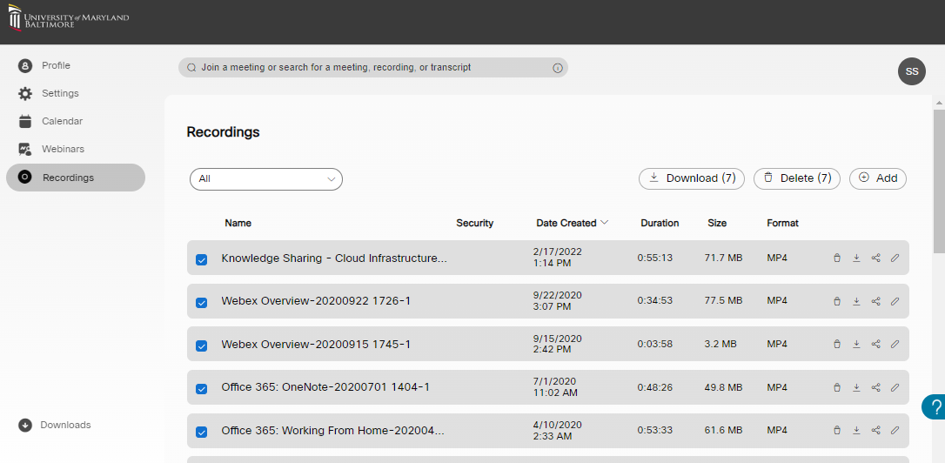
- In the pop-up that appears asking if you want to downlead, select Download.
- Another pop-up will appear in reference to Webex downloading multiple files – select Allow.
- The recordings will download to a default location, which is usually:
  - Local Disk (C:) > Users > Your User Name > Downloads
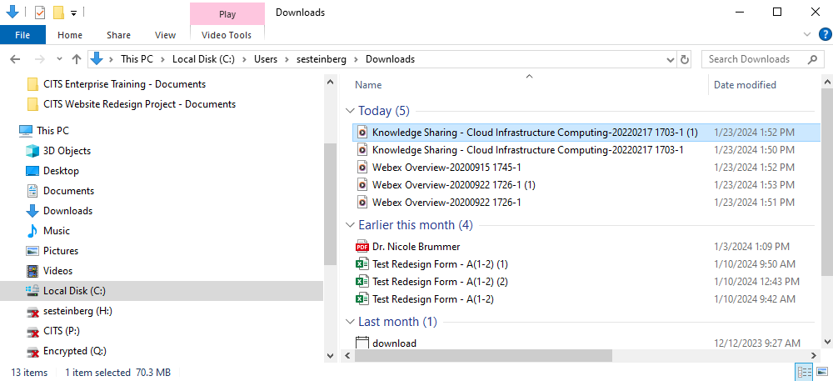
It is strongly recommended to then move the files to either a SharePoint or OneDrive location.
- Using the File Explorer (pictured above), the recordings can all be selected at once and then moved to another location.

