Office of the Controller Job Aid
Responsible Unit | Payroll | June 26, 2023
Title | CPB Net Pay Calculator

CPB’s net pay calculator NetPay Calculator (marylandtaxes.gov) can be used for estimating taxes and net pay.
Based on your paper paycheck or check advice, complete all sections
- Year, Residence, and County
- Earnings
- Exemptions
- Pre-tax deductions
- Retirement Deduction
- Supplemental Retirement Deductions
- Other Deductions
Click on [Submit]
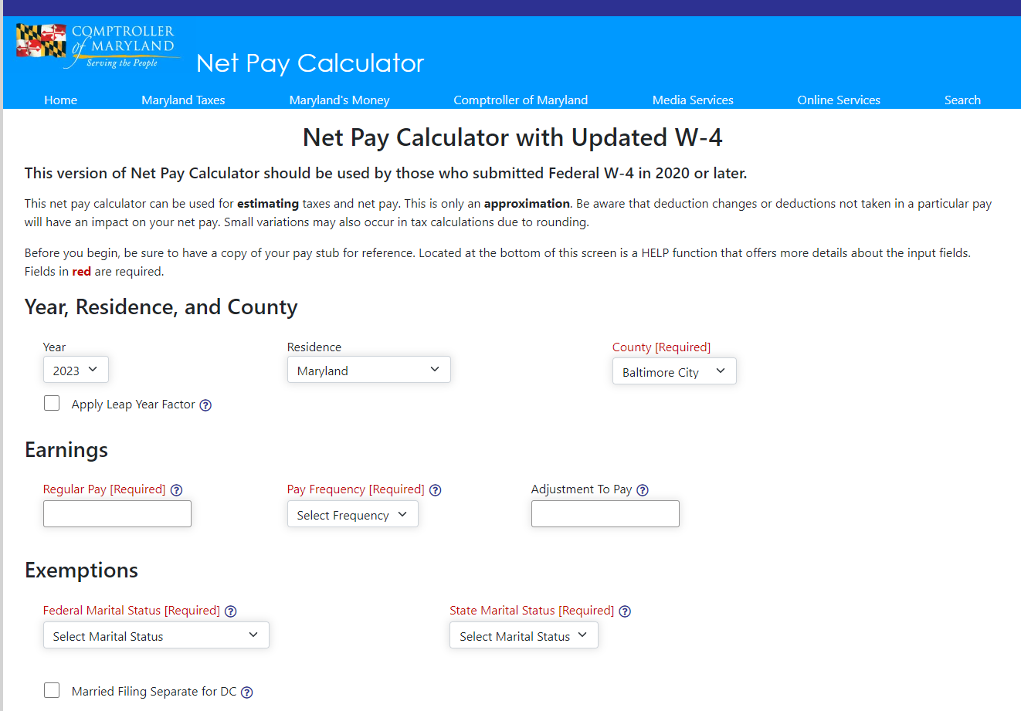

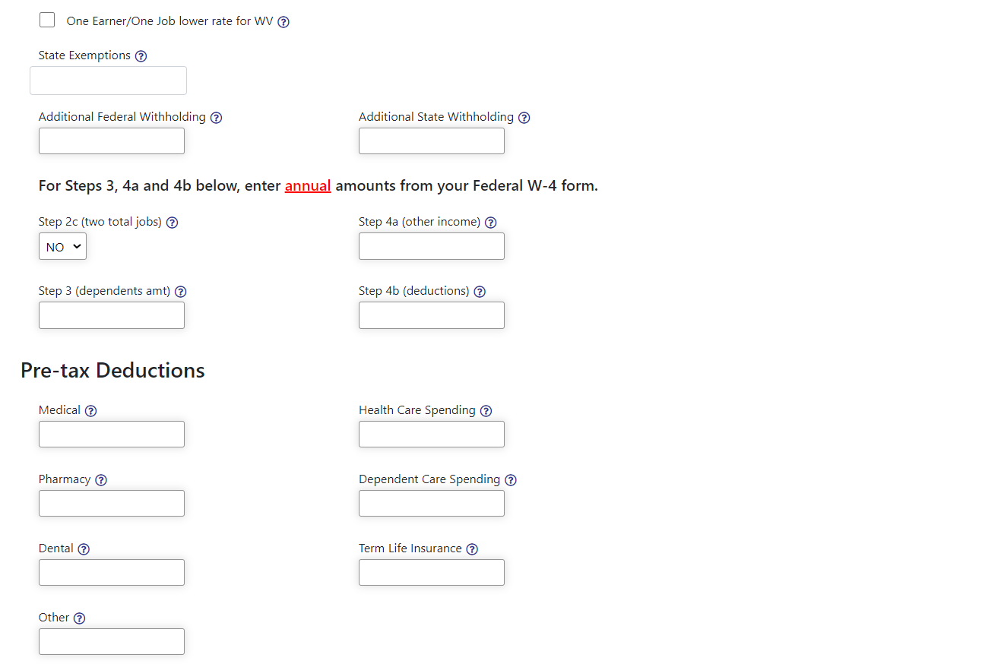
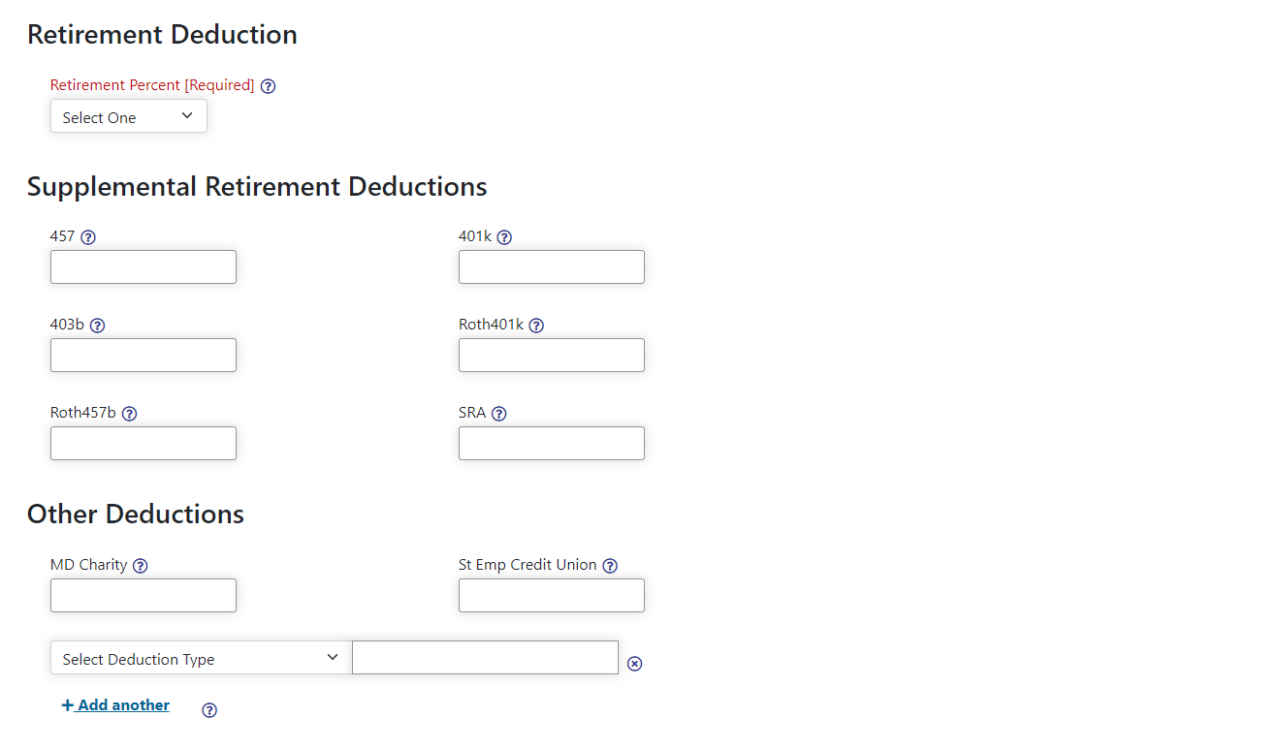

Below is an example of what you will see after submission. Once you can match your current paycheck, you can click on the [New Calculation] button and enter new numbers to estimate the taxes.
